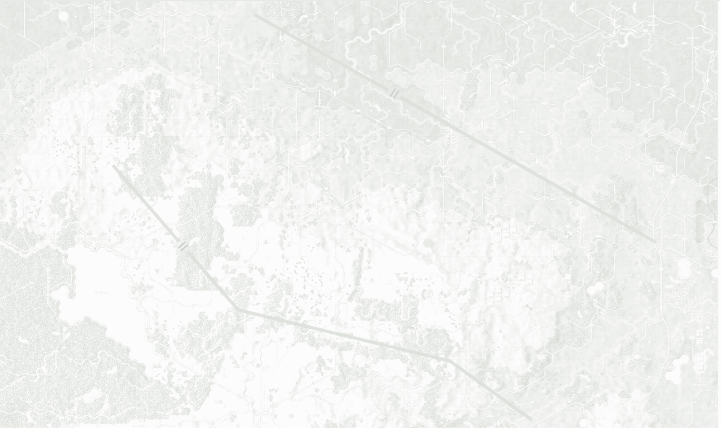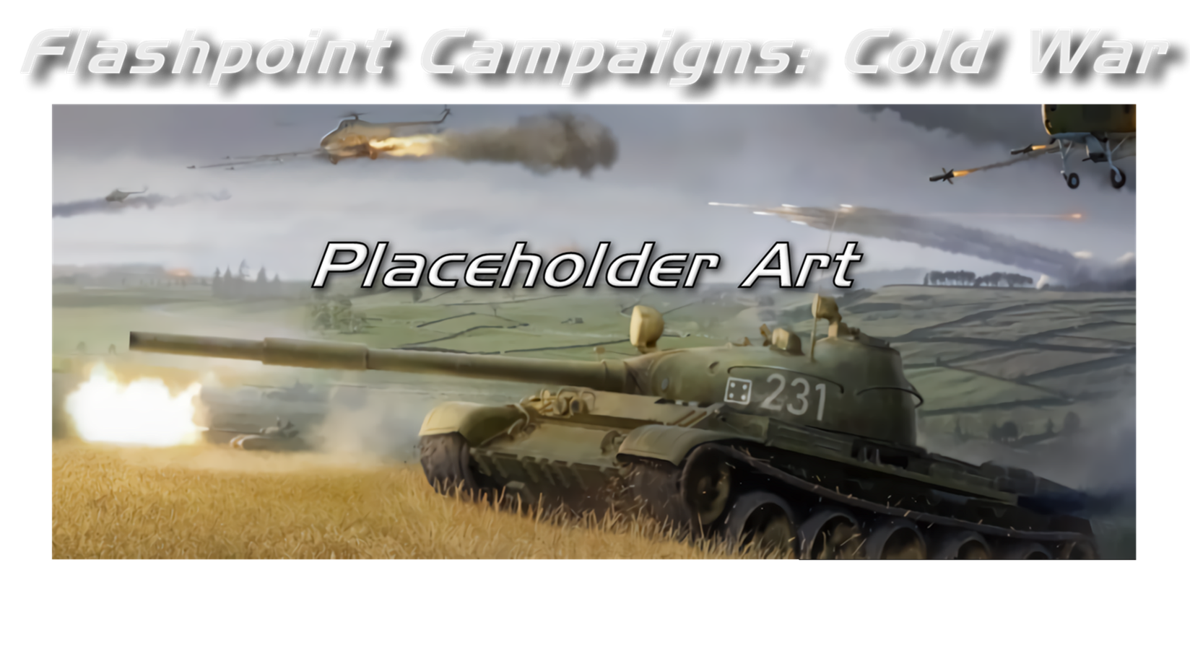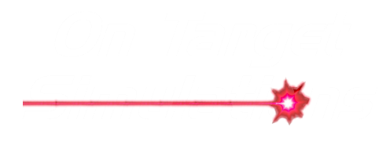

Scenario Design

Field Manual FCCW-04/R0

**© 2025 On Target Simulations, LTD. All Rights Reserved. The images used and OTS Logo are property of On Target Simulations, LTD. All other marks and trademarks are the property of their respective owners.**

Table of Contents

1 Introduction 5

1.1 What's in This Document 5

1.2 Manuals 6

1.2.1 The Field Manuals (FM) 6

1.2.2 What’s New 6

1.2.3 FPC Hotkeys 6

1.2.4 Flashpoint Campaigns: Cold War FAQ 6

1.3 Gender Pronouns and Inclusion 6

2 Getting Started 7

2.1 Scenario Creation Checklist 8

2.2 Edit Existing Scenario (Optional) 8

2.3 Scenario Editor Dialog Buttons 8

3 The Top Menu 8

4 Creating a New Scenario 9

4.1 Map and Weather Parameters 9

4.1.1 Selecting a Map 10

4.1.2 Setting up Scenario Weather 10

4.2 Scenario Parameters 12

4.2.1 Setting 12

4.2.2 Purpose of a Scenario 13

4.2.3 Scenario Description 13

4.3 Map Markers 14

4.3.1 Placing Map Markers 14

4.3.2 Victory Point (VP) Markers 15

4.3.2.1 Placing a VP Marker 15

4.3.2.2 Editing/Deleting a VP Marker 17

4.3.3 Bridge Markers 17

4.3.3.1 Adding a Bridge 18

4.3.3.2 Destroying a Bridge 19

4.3.3.3 Constructing a Bridge 20

4.3.3.4 Locking a Bridge 22

4.3.4 Marker Removal Functions 23

4.4 Additional Scenario Parameters 24

4.4.1 Air Superiority Levels 24

4.4.2 Electronic Warfare Intensity Levels 25

4.4.3 Other Scenario Limits 26

4.5 Player 1 Order of Battle 26

4.5.1 Creating a Force 29

4.5.2 Set Default Unit SOP 33

4.5.2.1 Scope 34

4.5.2.2 Stance 35

4.5.2.3 Combat 35

4.5.2.4 Movement 35

4.5.2.5 Transports 36

4.5.2.6 Recovery 36

4.5.2.7 Inspect and Apply 36

4.5.3 Adding to an Existing Force 37

4.5.4 Creating Additional Forces 38

4.5.5 Saving a Force 40

4.5.6 Loading a Force 40

4.5.7 Deleting a Force 44

4.5.8 Renaming a Force 45

4.5.9 Reorder Forces 46

4.6 Show Consolidated Order of Battle (OOB) 49

4.7 Show Force Roster 50

4.8 Deploying Forces on the Map 50

4.8.1 Placing Units on the Map 53

4.8.2 Deploying Units on and off Map 54

4.8.2.1 Deploying off-map Artillery Support 54

4.8.2.2 Deploying off-map Air Support 56

4.8.2.3 Deploying on-map Air Support 57

4.8.2.4 Deploying Reinforcements 58

4.8.3 Ammunition Loadout 60

4.8.4 Default Deployment Zones 63

4.9 Player 2 Order of Battle 63

4.10 Player Briefings 64

4.10.1 Best Practices for Mission/Threat Briefs 66

4.11 Mission Graphics 66

4.12 Scenario Summary 70

4.13 Scenario Details and Validation 71

5 Battle Plans 72

6 Altering an Existing Scenario 73

6.1 Editing Scenario using XLS 75

7 Updating Scenario Data 78

8 HTML Quick Reference 79

9 Some Scenario Design Do’s and Don’t’s 81

10 Flashpoint Campaigns Credits 83

10.1 On Target Simulations Team 83

10.2 Cold War Contributors/Testers 84

10.3 Cold War Beta Testers 84

10.4 Matrix Production Manager 84

OTS on the Web 84

# A military tank in a field AI-generated content may be incorrect.Introduction

Welcome to FLASHPOINT CAMPAIGNS: COLD WAR

This is a grand tactical combat simulation on the Cold War battlefield. As the force Commander, you will plan and then issue orders and Standard Operating Procedures to your battalion, brigade, or regimental forces, shaping the fight by maneuver and your intent. Your forces will engage the enemy on rendered real-world map locations. Each hex is 500m of militarily significant terrain. Each battle can last 4 to 24 hours of in-game time. Your troops will meet their foes any time of day and in any environment.

The game engine is based on asynchronous WEGO turns. This means you will issue orders and then watch a variable amount of time unfold on the battlefield. Then, issue or adjust orders to react to what has happened as you execute your battle plan.

***Flashpoint Campaigns: Cold War*** is a deep simulation of combat operations where your forces are arranged in maneuver units of companies, platoons, and sections of tanks, infantry fighting vehicles, infantry squads and teams, recon forces, engineers, air-defense and anti-tank systems, helicopters and more. As the Commander, you must use available off-map assets like long-range artillery, rockets, or airstrikes.

Your efforts in this complex battlespace will be constantly challenged by modeled features like Electronic Warfare, Air Superiority, Realistic Weather, Line of Sight and Fire, Terrain and Elevation, Smoke and Mines, and Human Factors like training, morale, and readiness. All these elements must be considered if you are to be victorious on the battlefield.

The game is packed with information dialogs, map overlays, and range rings to aid you as Commander, master the situation, and understand your force’s capabilities.

***Flashpoint Campaigns: Cold War*** is a data-rich simulation where each nation has information on National Characteristics, Command Parameters, and Orders of Battle. Data Tables are packed with era-specific equipment and troops. Weapon Systems of the time, such as guns, missiles, precision munitions, small arms, and much more, are comprehensively modeled.

As a toolkit, you can create your own scenarios and campaigns. You can also dive deeper and create or modify game data, artwork, and sound effects as you see fit. All these modding capabilities are supported by detailed documentation

## What's in This Document

This document describes how to create scenarios for the Cold War Game engine. It also covers editing existing scenarios and the tools for updating or changing data.

Although Battle Planning is part of the Scenario Editor and scenario creation, it is a large enough feature and new tool that we have given it its own FM to cover all its uses. A scenario can be made without battle plans and will run based on the improved AI from Red Storm. Battle Plans add more replayability and allow for more realistic setups for enemy AI forces.

**NOTE:** Areas of interest or buttons on form pictures are outlined in red.

**NOTE:** Some images in this manual are from other game versions. While your maps and units may differ, all the information and how it is used and displayed will match the information in this manual.

## Manuals

We have chosen to go with many living manuals to cover game interface/play, learning the game, basic tactics, Content Creation, and Game Modding for the Cold War game engine. We also have guides that cover that area of operations. The affected manuals and guides will be updated as the game is updated, and PDFs of these changes will be included with the new patches.

### The Field Manuals (FM)

These are the core manuals on how to play, create content for, and modify data for the Cold War game engine. Before jumping into Content Creation, we strongly recommend you review the first three manuals, **Game Operations**, **Battlefield Primer**, and **Tutorial Operations,** if you are new to this type of game and warfare. Returning Flashpoint Campaigns players should review **Game Operations** to get details on new features, as there are many.

These documents are found in the Documents\FMs folder.

* FM01: Game Operations – Detailed information on the game, its interface, and how to use it
* FM02: Battlefield Primer –Fighting in the Cold War
* FM03: Tutorial Operations – How to learn and play the game
* FM04: Scenario Design – ***This Manual*** – How to make or edit scenarios
* FM05: Battle Planning – How to create or edit battle plans
* FM06: Campaign Design –How to make or edit campaigns
* FM07: Map Construction –How to make simple maps for the game
* FM08: Game Engine Modifications - How to mod elements of the game engine
* FM09: Data Structures and Editing–How to edit or build data sets
* FM10: Weather Setup – How to add in weather from other locales

### What’s New

The What’s New PDFs summarize any changes and fixes when updates are released.

These can be found in the Documents\WhatsNew folder.

### FPC Hotkeys

This PDF document lists all the unique game key presses for Function keys and all hotkey definitions. Due to the large number of functions in the game, rebinding is not possible.

This document is in \Documents folder.

### Flashpoint Campaigns: Cold War FAQ

To stave off forum-clogging threads on various topics we either don't control or can't support, we created this FAQ document with the answers to those specific topics.

Please review the FAQ for answers to several game topics related to the game but not on how to play the game.

This document is in the \Documents folder.

## Gender Pronouns and Inclusion

We understand that users of all genders will play our simulation. We try to keep language in the game and manuals gender-neutral, when possible, but sometimes use the pronoun “he” to refer to the user. This is merely to streamline the writing, not to exclude anyone or note a specific gender.

The On Target Simulations team supports the inclusion of all people in the field of wargaming.

# Getting Started

Welcome to making content for the game system. The Scenario Editor, or ScenEdit for short, is a tool to make your scenarios with the supplied data and maps in the game.

Videos were made by On Target Simulations LTD making Scenarios and are posted at this link: [How to Create a Scenarios](https://www.youtube.com/watch?v=iULAXVVscbY)

To get started, select the “**Scenario**” button in the Edit section of the Main Menu, as illustrated in Figure 1.

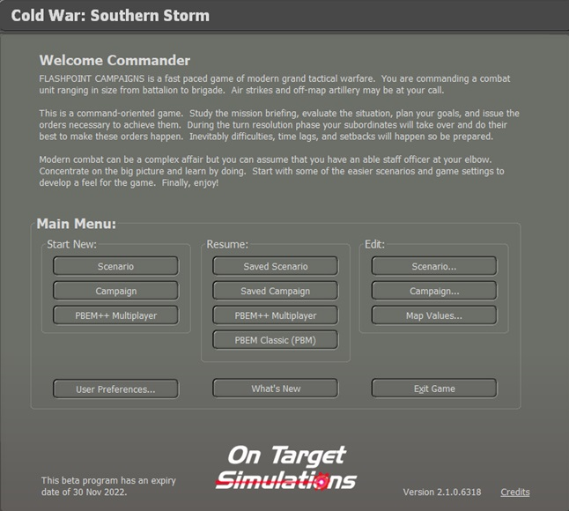

Figure

Clicking the “**Scenario**” button will launch the Scenario Editor. It may take a few minutes for the editor to load up and show you a map (the first map in the list by name, you can change it later to the one you want to use), mini-map, menu bar, and the main Scenario Editor Dialog, as illustrated on Figure 2. We will use these tools to make a small scenario.

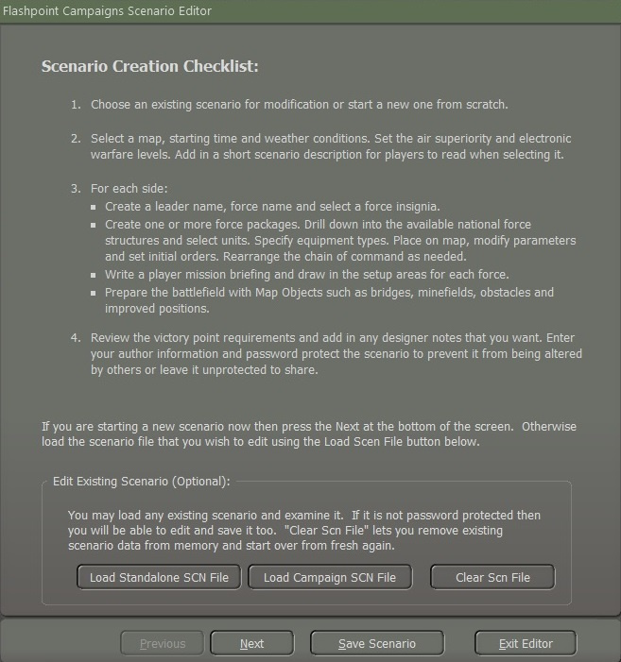

Figure

## Scenario Creation Checklist

It would help if you took a minute and read through the Scenario Creation Checklist on the starting page of the dialog for some critical information on using the editor.

## Edit Existing Scenario (Optional)

There are a few options here to edit existing scenario files via the different buttons, and they are as follows:

* **Load Standalone SCN File** – This option will open the Scenario Listing for the current module (Southern Storm for now). The same filters and selection options from playing a game are here. You can select a scenario to edit with your changes and then save it with a new or altered name or open a new scenario you're working on to alter or complete it.
* **Load Campaign SCN File** – This option will open the Campaign Scenario Listing for the current module (Southern Storm). The same filters and selection options from playing a game are here. You can then select a scenario to edit with your changes and save it with a new or altered name or open a new scenario you are working on to alter or complete it.
* **Clear Scn File** – This button will wipe all the data for the currently selected scenario from the game so you can start fresh. **NOTE:** There is no undo from this, so be sure you want to dump everything.

If you plan on editing an existing scenario, that information is covered in Section 6 below.

## Scenario Editor Dialog Buttons

At the bottom of the main Scenario Editor dialog are four buttons that stay in place as the pages change. These buttons have the following functions.

* **Previous** – Return to the previous page in the Scenario Editor dialog.
* **Next** – Move to the next page of the Scenario Editor dialog.
* **Save Scenario** – Opens up the Scenario Save dialog box where you can give the scenario a name or save over your existing scenario build/design. If you are changing an existing scenario (someone else's work), please make a name adjustment or rename to avoid confusion or overwriting game content.
* **Exit Editor** – This button exits the Scenario Editor ***WITHOUT*** saving any information or changes.

Since starting a new scenario, we must select the “**Next**” button and read Section 4 below.

# The Top Menu

The Top Menu for the Scenario Editor is nearly the same as the in-game menu except for the first entry, which is now called “Scenario Editor” as seen in Figure 3.

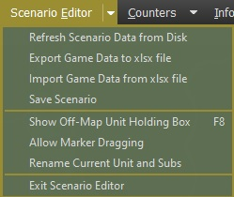

Figure

* **Refresh Scenario Data from Disk** – Use this menu item to update all the unit data in the scenario if the game data is updated. See Section 7 below for details on how to use this function. It would help if you had a scenario loaded to activate.
* **Export Game Data to XLSX File** – Use this menu item to export scenario data to a tabbed Excel spreadsheet where you can edit certain information. It must have a scenario loaded to activate. See Section 6 below.
* **Import Game Data from XLSX File** – Use this menu item to load data for a scenario from a selected Excel spreadsheet that has been edited. See Section 6 below for details on how to use this function. It must have a scenario loaded to activate.
* **Save Scenario** – Opens the Save Scenario dialog. Scenarios can be saved in an incomplete state so you can come back and finish them later.
* **Show Off-Map Unit Holding Box** – This opens the Off-Map Holding box to show what units are in the game but located off-map. You can edit the parameters of those units from this dialog.
* **Allow Marker Dragging** – Checking allows you to click on and drag map markers to new locations. Unchecking this will lock the markers in place and make sure you don’t accidentally move a marker when working with units and plans.
* **Rename Current Unit and Subs** – If a unit is selected on the map or from the off-map holding box, you can use this function to rename the units in the dialog box that pops up.
* **Exit Scenario Editor** – Exits the Scenario Editor and sends you back to the Main Menu.

# Creating a New Scenario

In the following sections, we will go through a step-by-step process of setting up a simple scenario with all the various types of units added in and the game setting adjusted.

We will also add a battle plan for each side, but that information can be found in **FM05:** **Battle Planning**. You will need to open that document when the time comes to see all the functionality of the Battle Planning process.

## Map and Weather Parameters

After clicking the "**Next**" button, the initial window that appears is the Map and Weather Parameters page. This page allows users to select both the map and the potential weather conditions for the scenario. The Map and Weather Parameters window is seen in Figure 4.

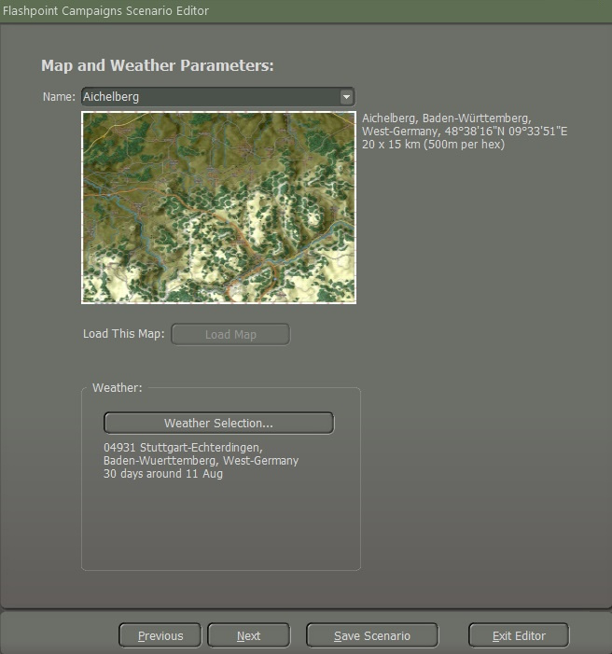

Figure

### Selecting a Map

Choose a map by clicking on the (**1**) “Name” dropdown menu as seen in Figure 4, which will display a list of all available maps in the selected game module as illustrated in Figure 5. Scroll through the list to view all the names of maps.

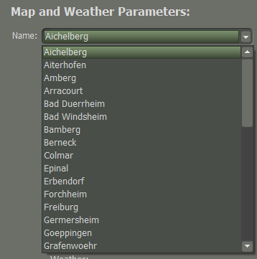

Figure

Upon selecting a map, a mini-map image of the area will appear, accompanied by detailed map information on the right, including the name, and size as illustrated in Figure 6.

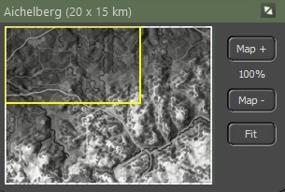

Figure

1. The top bar shows the name of the map and its dimensions in parentheses.
2. The yellow outline shows what part of the map is currently visible on the screen based on the level of zoom currently selected and the location on the main map.
3. This is the full Mini-Map in greyscale. Clicking anywhere on the map will recenter the visible map on the game screen.
4. The “**Map +**” and the “**Map –**” buttons will increase or reduce the map size. Below the “**Map +**” button is a scale of the map when you adjust the size.
5. The “**Fit**” button will make the map fit the full screen.

Once you find a suitable map, click on the (**2**) “**Load This Map**” button to load the selected map into the editor as seen in Figure 4.

### Setting up Scenario Weather

One of the important aspects of scenario creation is establishing what the weather will be during the battle.

The Weather Selection editor allows you to set up a range of possible historical weather patterns or you can tailor the weather to meet your needs. This information is then used to dynamically generate the weather for the scenario and is used to provide the weather forecast seen in the game so players can get an idea of how the weather will impact the fight.

Click the (**3**) “**Weather Selection**” button to open the “Select Weather” dialog as seen in Figure 4. The noted area in the dialog is described below.

In the User Preferences dialog, you may switch between Metric and Imperial units for the weather information.

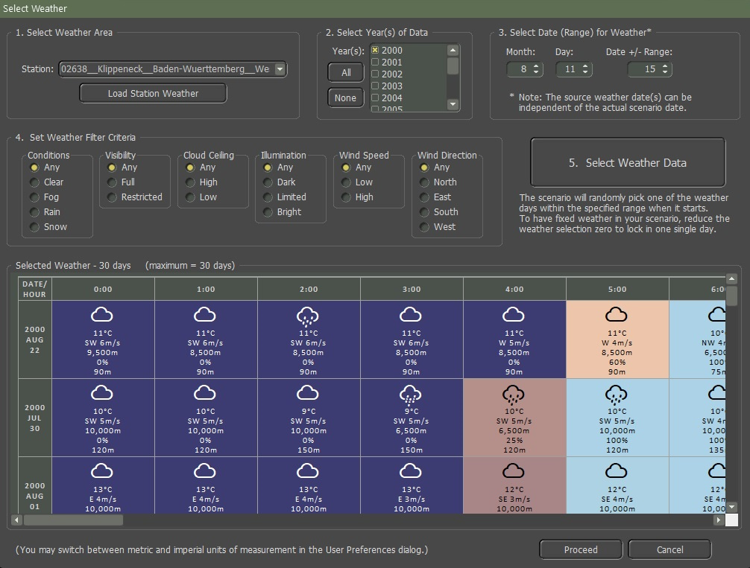

Figure

1. **Select Weather Area** – In this section of the weather settings, you can set the location for the weather information as illustrated in Figure 8. By default, the weather data for the map loaded will be set here. You can use another area or custom map data if you have created any.

See **FM10: Weather Setup** for details on making your weather setup files.

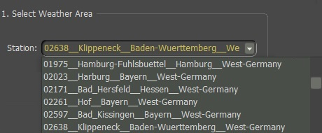

Figure

It would help if you highlighted the weather station and then select the “**Load Station** **Weather**” button.

**2. Select Year(s) of Data** – Based on the weather data file loaded, several years can be selected to increase the number of weather days in the date range and filter criteria. You can add all the years by selecting the “**All**” button which will highlight them all or you can use the “**None**” button which will deselect all the years. You can select each year you want by selecting the years individually.

**3. Select Data (Range) for Weather** – By default, this date matches the date set for the scenario. You can change the date and adjust the +/- number of days around that date to select weather from.

**4. Set Weather Filter Criteria** – You can set any, all, or none of these items to filter the weather for the date to more of the conditions you want for the scenario.

**5. Select Weather Data** – Once you have set all the parameters you want, click the “**Select Weather Data**” button to fill the Selected Weather Information table and see the results of your selections. If no selections are shown, you may need to change some of the filters, add more years, or increase the date range.

**6. Selected Weather Information** – This shows you the weather for the selected days up to a max of 30 possible weather patterns that may be used in the scenario.

The more options shown in this table, the more possible weather patterns could appear in the game. Each cell of the table shows the Weather Type by icon, Temperature, Wind Speed and Direction, Maximum Visibility, Illumination Level, and Cloud Ceiling as illustrated in Figure 7.

When you are good with the selected weather, click the “**Proceed**” button. Once you select the “**Proceed**” button it will take you back to the Map and Weather Parameters window, select the “**Next**” button to go to the next pop-up window which will be the “Scenario Parameters”.

## Scenario Parameters

Creating a scenario involves defining various parameters to shape the narrative, setting, and context of the story or situation. Here we will create the (**1.**) Setting, (**2**.) Purpose of the Scenario, and (**3**.) Scenario Description as illustrated in Figure 9.

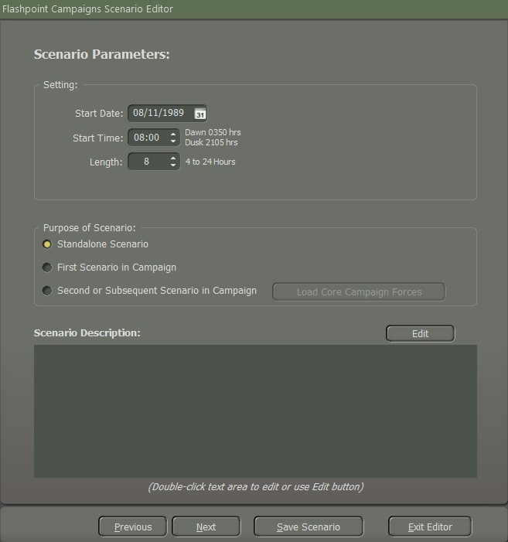

Figure

### Setting

These set the date, time, and duration for the scenario. This is the starting point of making a new scenario standalone or for a campaign.

* **Start Date** – Use the text field or the calendar button to set the Month, Day, and Year of the battle. This sets the possible equipment that can be used in the scenario.
* **NOTE:** the game data is focused on 1980 to 1989. Setting dates outside of this range will result in not being able to fill formations with equipment, as available dates can be exceeded.
* **Start Time** – This is the time of day for the start of the scenario. Based on the Map being used and the Start Date, the times for the start of Dawn and Dusk are noted so you can set the time to be day or night or in the transition between the two. **NOTE:** Night scenarios will favor the NATO forces if they are equipped with thermal sights.
* **Length** – This is the length of time in hours for the scenario to play out. The bigger the map or size of the battle, the more time you may wish to start with. In most cases, 4 to 8 hours is enough time for most types of battles.

### Purpose of a Scenario

The Purpose of Scenario selection here is to establish the type of scenario being created.

* **Standalone Scenario –** Select this option if you are making a single scenario that can be played on either side.
* **First Scenario in Campaign** – Select this option if you are making the first scenario of a campaign. Campaigns are single-sided battles where one side is always the player with a core force of units versus the AI (Battle Plans you will create for the AI side, see **FM05: Battle Planning**). Creating a Campaign is covered in **FM06: Campaign Design**.
* **Second or Subsequent Scenario in Campaign** – Select this option if you are working on any additional scenarios for an established campaign. Once selected, the Load Core Campaign Forces will be enabled, and you can click this to load the core forces for the campaign you are working on.

### Scenario Description

At the bottom of the first panel is the “Scenario Description” text box. The scenario description is used to tell players the background information that sets up the battle, but not mission specifics for each side. That is done later in the editor.

Clicking on the “**Edit**” button or double-clicking inside the text box will open the Create Scenario Description editor as shown in Figure 10.

The Plain Text Editor allows you to write your text narrative for the scenario and use simple HTML5 tags to enhance the look of the Scenario Description. See “**Section 8. HTML Quick Preference**” for HMTL tags.

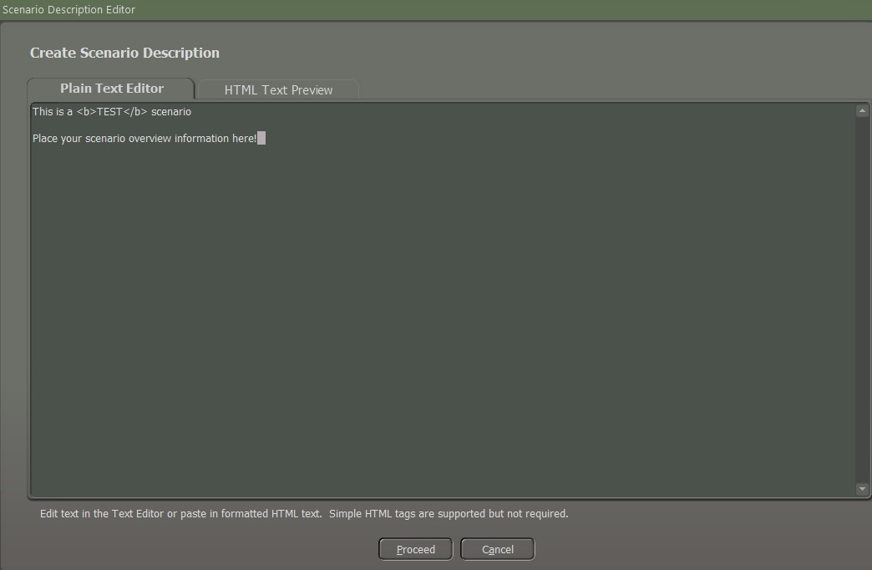

Figure

Clicking on the HTML Text Preview tab will display the formatted version of your Scenario Description. Once you are done with your scenario description and how it looks, you can click the “**Proceed**” button to save it as shown in Figure 10. Your Scenario Description will now show in the Scenario Description window.

You can reopen this anytime to add or change information or formatting.

Click the “**Nex**t” button to move to the next dialog page.

## Map Markers

When designing a scenario, you can add several map markers to the game map that have various functions as illustrated in Figure 11.

These functions include map obstacles like mines, NBC contamination, fortifications, smoke, bridges, and Victory Point (VP) markers. The dialog shown below shows most of those markers.

The markers in the three lists represent markers by the player side and a set of neutral markers in yellow that can affect all units on the map. Side-specific markers in Blue for side one or Red for side two only impact the other side when a marker is encountered.

These markers on this dialog are optional and should be used to enhance your scenario where needed. Many of these markers have both full hex and hex edge trigger versions.

Smoke and Gas (from non-persistent attacks) can be found in the Neutral Map Objects listing.

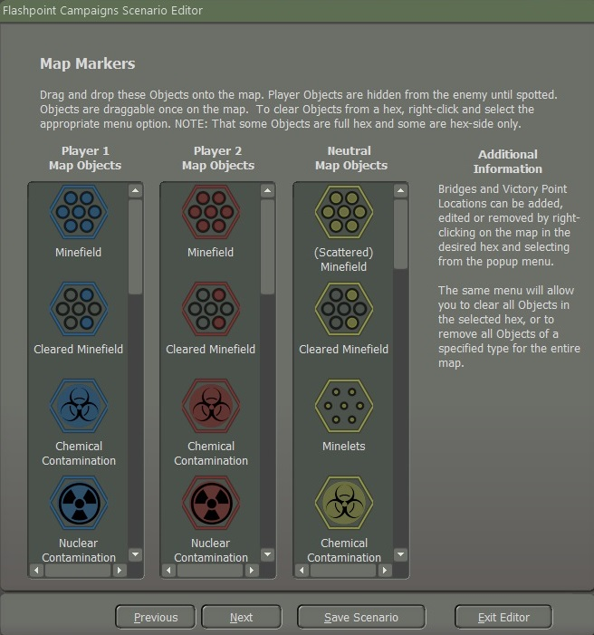

Figure

### Placing Map Markers

To add a map marker, click on it in the dialog and drag it to the hex you want on the map as illustrated in Figure 12. Most markers cannot be placed on each other. The exceptions are markers like smoke, gas, and NBC effects. These markers can be placed over hex and hex edge markers.

Once you have all the markers on the map and you want to protect them from being accidentally moved when doing other actions like placing units, click on the Scenario Editor main menu bar and uncheck the Allow Marker Dragging option as shown in Figure 3. This will save on some possible frustration later when tweaking things.

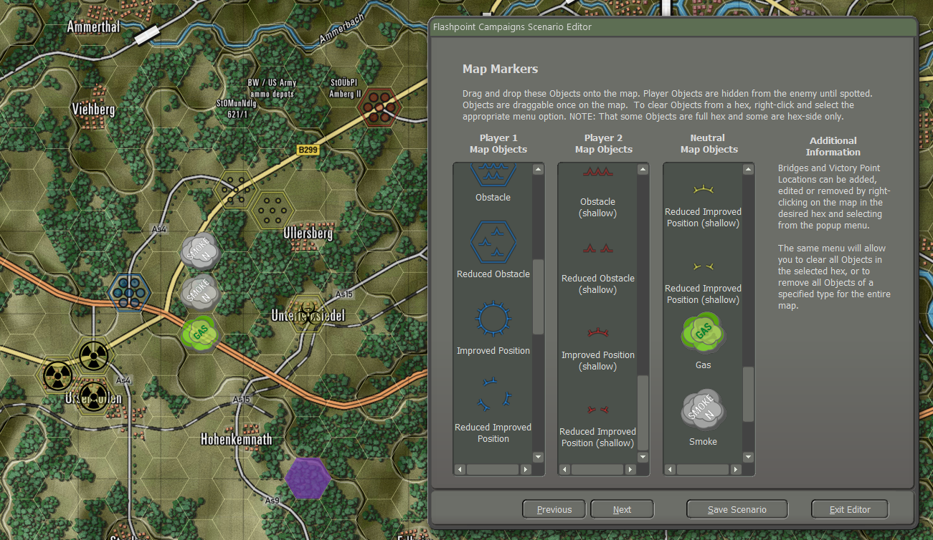

Figure

Another trick that might help place markers is to select Options from the Menu and then go to Map Contrast Options and set it to Strongly Muted Map Terrain, so the map is less colorful, and the markers stand out more.

### Victory Point (VP) Markers

Victory Point Markers or VPs for short, are used to provide two important scenario design functions.

First, VPs are used to place important objectives on the map that both the player and the AI will be attacking or defending as the main aspect of the scenario. As a scenario designer, you can use VPs as a means of giving the AI player a sense of influence as to where it should go. When coupled with Battle Plans, VPs become the endpoints where forces will go during the battle.

The second function of VPs is to provide points to the side that controls the VP location at the end of the battle.

The values of the VPs should be tailored to meet the mission objective and to balance out VP point scoring with the value of each side’s forces.

#### Placing a VP Marker

* **Placing VPs** – To place a VP marker on the map, right-click in the target hex and select “Add/Edit/Remove VP Location” from the Popup Menu as illustrated in Figure 13.

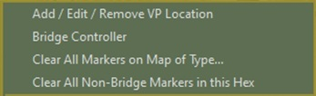

Figure

* **VP Ownership** – Each VP must have one of the three Ownership states as illustrated in Figure 14. The VP can be owned by Player 1. In this case, the AI will set up and defend the location if in the area and the enemy will move to take the location if in the area. The VP can be owned by Player Two with the same effect on the AI.

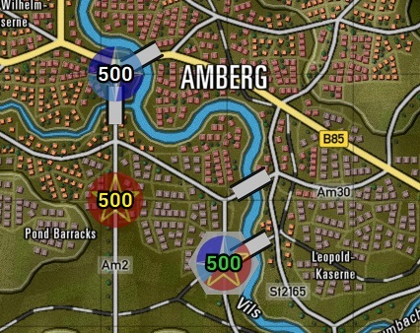

Side One VP

Side Two VP

Unclaimed

Figure

A location can be Unclaimed or owned by neither side and both sides will attempt to take them if forces are nearby. You use these ownership states to craft the time of battle. Attack/Defend scenarios are set with one side owning markers and Meeting engagements can be made using Unclaimed markers. Mixing these with various Battle Plans keeps the game dynamic for the players.

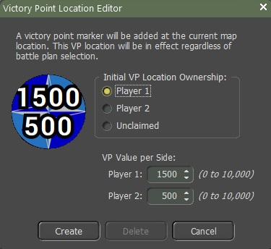

Figure

* **VP Value** – A new feature in Southern Storm is the ability to have split value VPs to allow you to better shape the mission objectives by having a location have more value and AI weight for a side as illustrated in Figure 15. You can enter a value or use the value spinners to set each of the values.

When you are happy with the ownership and values, click the “**Create**” button to place the marker in the selected hex as illustrated in Figure 16.

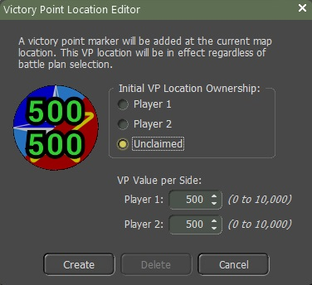

Figure

#### Editing/Deleting a VP Marker

If you need to tweak the value or ownership of a VP or remove it, select, and right-click the VP hex and the dialog will pop up as illustrated in Figure 17 with the selected VP’s information in the dialog box.

You can edit the values and ownership and click the “**Update**” button or if you wish to remove the VP from the map, you can click the “**Delete**” button.

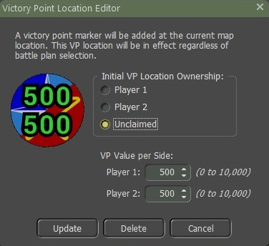

Figure

### Bridge Markers

While the game engine will automatically add all required road and rail bridges to the map, you still can “blow up” bridges to show engineering actions before a battle or even add additional temporary bridges (again from pre-game engineering actions) to possible crossing areas on the map.

Basic bridges are shown on the map as white rectangles with hard black long edges. Bridges owned by one side will be blue or red in place of the white color as illustrated in Figure 18.

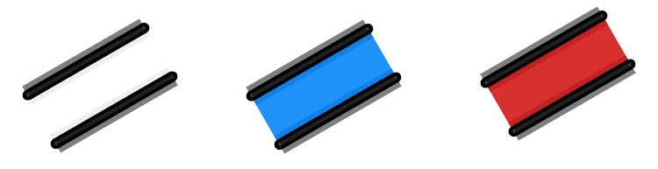

Figure

If you want an engineering unit to construct a bridge, the bridge will resemble what is illustrated in Figure 19. Once the bridge is completed, it will transform from the construction phase depicted as illustrated in Figure 18 to its finished state.

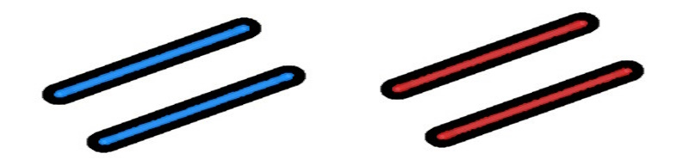

Figure

If you destroy a bridge, a red cross will appear over the bridge. This bridge is no longer capable of allowing units to pass over it as illustrated in Figure 20.

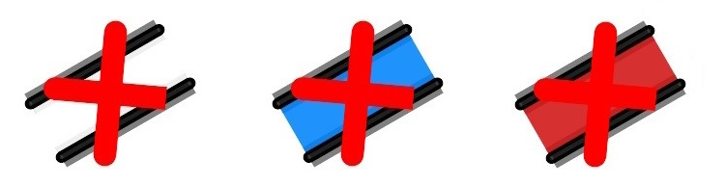

Figure

#### Adding a Bridge

To add a bridge, you need to select a hex next to a water obstacle and then right-click to bring up the Popup Menu, and then select “Bridge Controller” as illustrated in Figure 21 to open the dialog.



Figure

The first thing to decide for the new bridge is Ownership. If it is a public bridge (existing before the battle or being used as a fording point) set it as Public. If the bridge is being used to represent a placed engineering bridge before the scenario starts, you can select the side by setting it as Player 1 or Player 2. These will show as blue or red respectively.

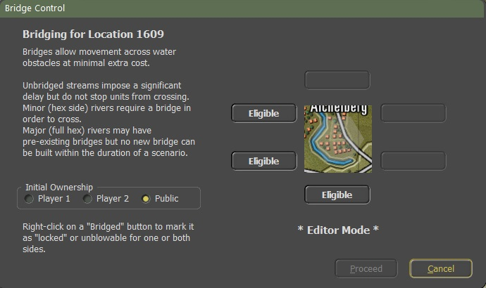

Figure

On the right side of the dialog, is the editor portion of the bridge placement tool. The selected hex is shown in the middle and the surrounding six sides will show eligible locations to add a bridge.

Here we only have three places to place a bridge as shown in Figure 22. Clicking the “**Eligible**” button will add a bridge at that location on the map and change the button to Bridged. Clicking the “**Proceed**” button will add the bridge to the map and close the dialog.

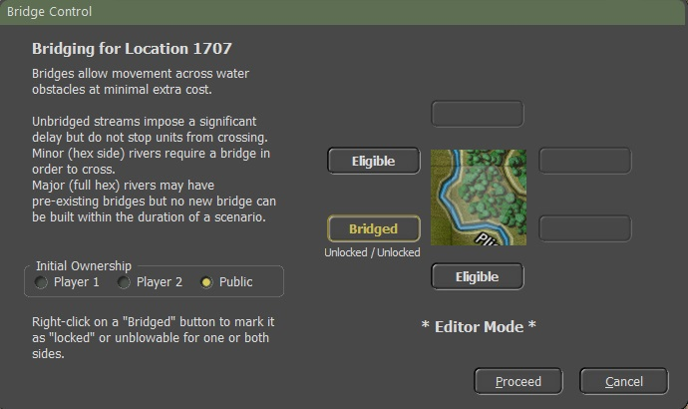

Figure

To remove a bridge, select the hex where the bridge is and open the Bridge Control dialog. Click the Bridge button twice to set it back to Eligible and then click the “**Proceed**” button to remove the bridge from the map.

#### Destroying a Bridge

Depending on the design of the scenario, you may want to have some of the bridges destroyed (before the scenario by engineers) to restrict travel during the battle.

To destroy a specific bridge, select a hex with the bridge in question and right-click that hex to bring up the Bridge Control.

As seen on the right, eligible bridges will be denoted with Bridged. Click on this button to switch it to Blown as illustrated in Figure 24.

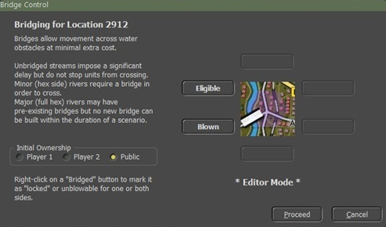

Figure

Once you click the “**Proceed**” button, the bridge will be marked as destroyed on the map as illustrated in Figure 25. You can undestroyed a bridge by selecting it and clicking the button back to Bridged.

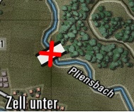

Figure

#### Constructing a Bridge

Lay/Recover Bridge – Allows an Engineer Short-Span Bridging vehicle to place or retrieve a temporary bridge over a hex-side water obstacle.

Engineering Bridging Unit must be next to a river hex, right click on an Engineer Bridging Unit which causes a popup screen to appear as shown in Figure 26, and select “Build Bridge.”

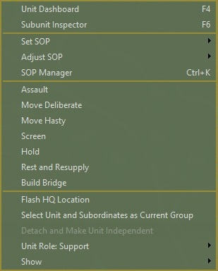

Figure

Once you click on “Build Bridge” a screen will pop up as seen in Figure 27.

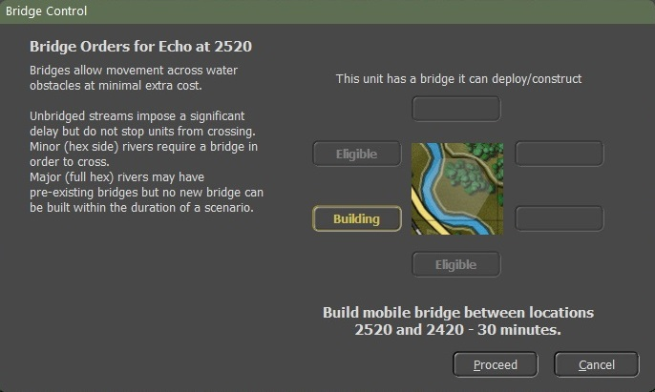

Figure

There were three eligible locations, select the “**Eligible**” button where you want the bridge to be built and it will turn into a “*Building*” button as illustrated in Figure 27. The Bridge Controller will state where and how long it will take to finish the building. Click on the “Proceed” button to start the building of the bridge.

There will be a Time Stamp in between the graphic symbol for constructing a bridge, which is 1700 hrs. when the bridge is completed as illustrated in Figure 28.

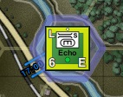

Figure

You can tell an Engineer Bridging Unit to move to a location by a river where you want to build a bridge. When you plot your waypoints to the river a popup screen will display as shown in Figure 29. Select the “Build Bridge” button.

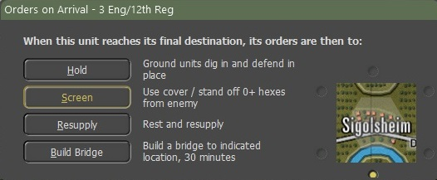

Figure

Once the Engineer Bridging Unit gets to the location it will start to build the bridge with a time stamp indicating when it will be finished building as illustrated in Figure 30.



Figure

Figure 31 shows the bridge completed.

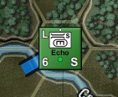

Figure

Now to recover the bridge, right-click on the bridging unit, and a popup display as shown in Figure 32. Select the “Remove Bridge”.

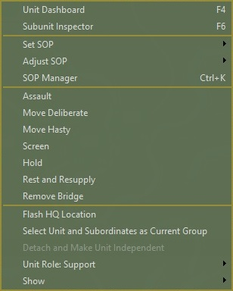

Figure

Once you select “Remove Bridge” another screen “Bridge Controller” will pop up as seen in Figure 33.

To retrieve the bridge, the Engineer Short-Span Unit must not have a bridge. “**This unit has no bridge equipped and can recover** a **bridge**” will be shown in Figure 33. If the unit has a bridge already it would state “**This unit can demolish/blow a bridge**”. Select the “Bridge” tab which will change to “Recovering”. It will state the location and how long it will take to recover the bridge as shown in Figure 33. Select the “**Proceed**” button when ready to remove the bridge.

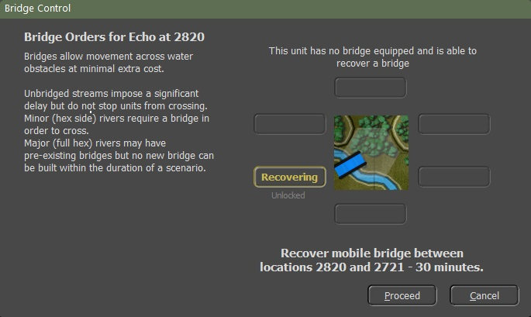

Figure

#### Locking a Bridge

In some scenarios, you may wish to lock bridges from being blown by the players if they have engineering assets in the battle.

If you select the bridge on the map right-click to bring it up and select the Bridge Control dialog you get the dialog as seen in Figure 26.

Right-click on the Bridged button and a pop-up menu will appear allowing you to lock the bridge from demolition by either side or both sides. You can go back later and unlock by bringing the dialog up, bringing the popup menu up, and selecting the unlocked option. Clicking the “**Proceed**” button will make the change on the map.

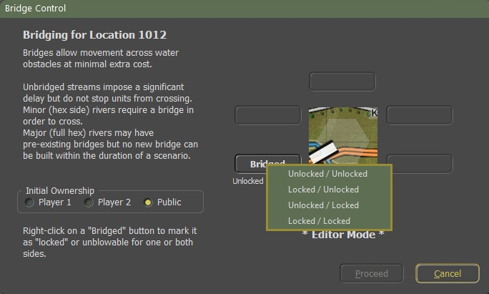

Figure

### Marker Removal Functions

After you place markers on the map, you may need to remove some or even all those markers from the map when editing the scenario. To remove markers of different types across the entire map you need to right-click in a hex on the map and select the “Clear All Markers on Map of Type...” option on the pop-up menu as shown in Figure 35.



Figure

Doing that opens the dialog” Remove Map Markers” as seen in Figure 36.

You can then check or uncheck any combination of markers that need removal. Once the selection(s) are complete, click the “**Proceed**” button to have them taken off the map. There is no undo for this, so be sure that you want to remove them.

**NOTE:** If you select All Bridges and remove them, you will need to either add them back in manually or reload the map and start over. In most cases, there is no need to remove all bridges in a scenario design.

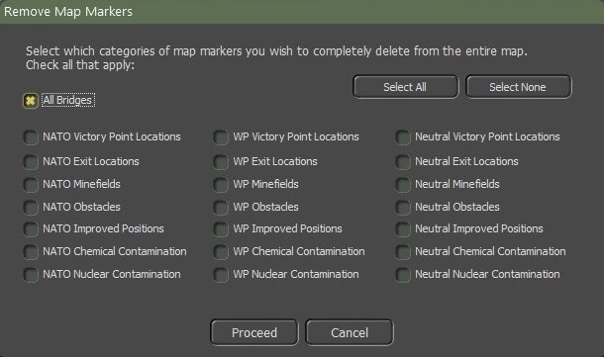

Figure

If you want to just remove non-bridge markers in a hex, right-click on the hex with the marker(s) to remove (should highlight) and select the “Clear All Non-Bridge Markers in this Hex” option from the pop-up menu as shown in Figure 37. The marker(s) in the hex will be removed and the menu closed. Like the other removal functions, there is no undo here, so be sure you want to remove them before clicking the menu item.

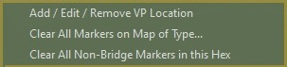

Figure

## Additional Scenario Parameters

The next page in the Scenario Editor panel is the Additional Scenario Parameters page. This page allows you to set the (**1**.) Air Superiority Levels, (**2**.) Electronic Warfare Levels, and the (**3**.) Maximum Resupply Percentage. All these factors apply across the length of the scenario. The page appears as seen in Figure 38.

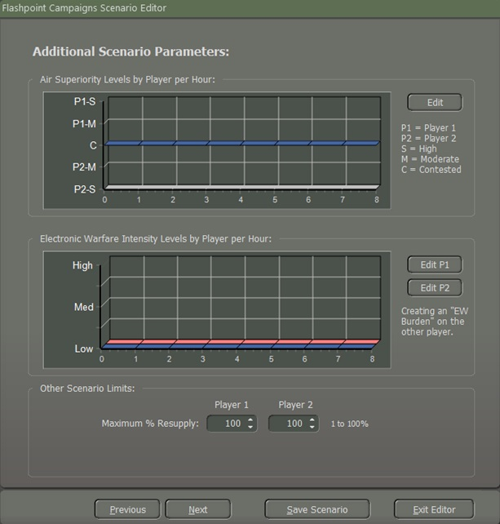

Figure

### Air Superiority Levels

The top graph (**1**) represents the presence of fighter aircraft used to clear the skies of close air support and other enemy aircraft and helicopters over the battlefield. The greater the presence of a side’s Air Superiority, the greater the chance that enemy air strikes and even on-map helicopters run a risk of being engaged and shot down or in the case of air strikes runoff, so they do not attack.

Even when the airspace is Contested, both sides run a small risk of getting engaged and losing forces. During the game, any Air Superiority actions will appear on the screen as a dialog message telling players what has happened.

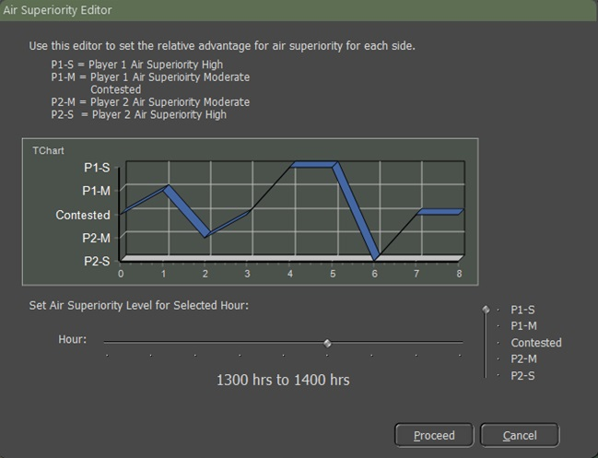

Figure

To set the levels seen in Figure 38, click on the “**Edit**” button to open the panel as illustrated in Figure 39.

Then set the Level of Air Superiority on the right (up for player one control or down for player two control) for each Hour of the scenario. Move the Hour control to each position to set the next Hour’s Level.

As you make these changes the graph will change to reflect the settings. The blue color graph represents “NATO” while the red color graph represents “Warsaw Pact”. This information is reflected in reports for both sides of the scenario when it is played. Once you set the levels click the “**Proceed**” button

### Electronic Warfare Intensity Levels

The bottom graph (**2**) shows the levels of Electronic Warfare both sides are projecting into the battlefield to jam and spoof communications making it harder to issue orders.

To set the levels as seen in Figure 38 for each player click on the “**Edit P1**” or “**Edit P2**” buttons. Then set the Level of Electronic Warfare on the right (up for more interference or down for no interference) for each Hour of the scenario. Move the Hour control to each position to set the next Hour’s Level as illustrated in Figure 40. As you make these changes the graph will change to reflect the settings. This information is reflected in reports for both sides of the scenario when it is played. Once you set the levels click the “**Proceed**” button

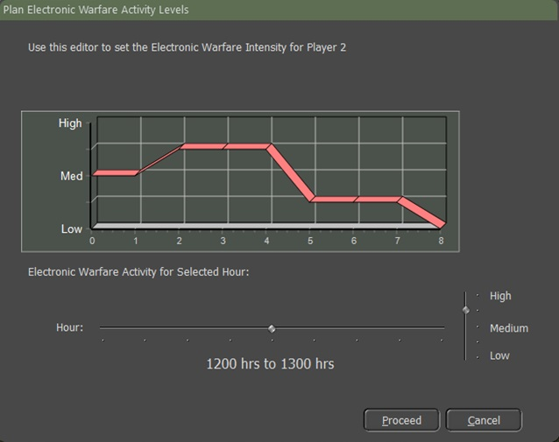

Figure

### Other Scenario Limits

Now, The Other Scenario Limits (**3**) section of the dialog sets the maximum resupply level for the sides shown in Figure 41. This setting can be used to reflect limited resupply to a side during a battle. To set the value, either enter a value from 1 to 100 in the text box or use the spinners to set a value.

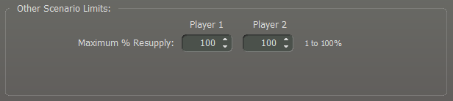

Figure

Once these items have been set, click the “**Proceed**” button to move to the next dialog page.

## Player 1 Order of Battle

Now we get to the business end of the editor. This involves choosing and strategically positioning forces both on and off the map. Player One represents the “NATO” side. In Section 4.9 Player 2 Order of Battle, you'll be able to incorporate forces for the “Warsaw Pact”. Let's walk through the steps together.

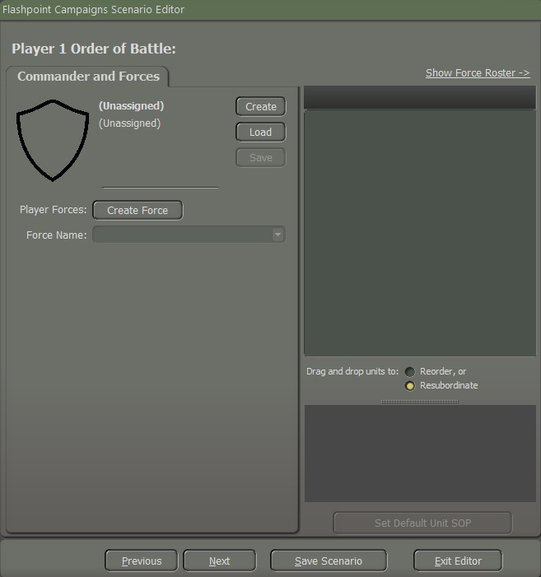

Figure

1. Click on the “**Create**” button to open the following Commander Selection dialog as illustrated in Figure 42.

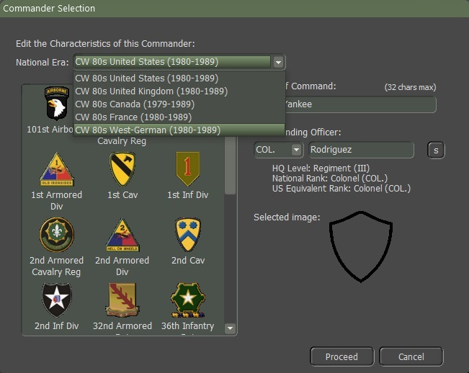

Figure

1. Select the Commanding Nation by using the drop-down as shown in Figure 43. Other forces can be added from other countries, but there must be one Commanding Force selected for the scenario.
2. In this case, the West Germans were selected. In this window, you can select a badge for the force. Some forces have many selections representing various historical formations and others like the West Germans have quite a few. After selecting a badge, the Force name will change to match the badge selected. Click on the “Confirmation” dialog to accept or reject the name change.

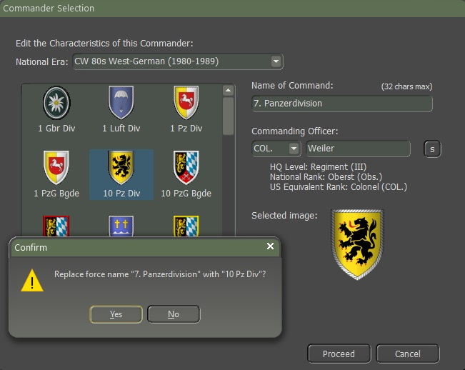

Figure

1. In the Name of Command text box, you can also rename the Command by typing in a name up to 32 characters in length.
2. You can select the Rank from the dropdown and change the randomly selected surname of the Commander. You can type in your name up to 24 characters or hit the “s” button to have one randomly selected from the Nation Datasheet Surnames listing. Click on the” **Proceed**” button when done with the Name and Rank selection.
3. Upon closing the Commander Selection dialog, you will find three buttons positioned to the right of the Player 1 Order of Battle display as shown in Figure 45, enabling you to perform the following actions:

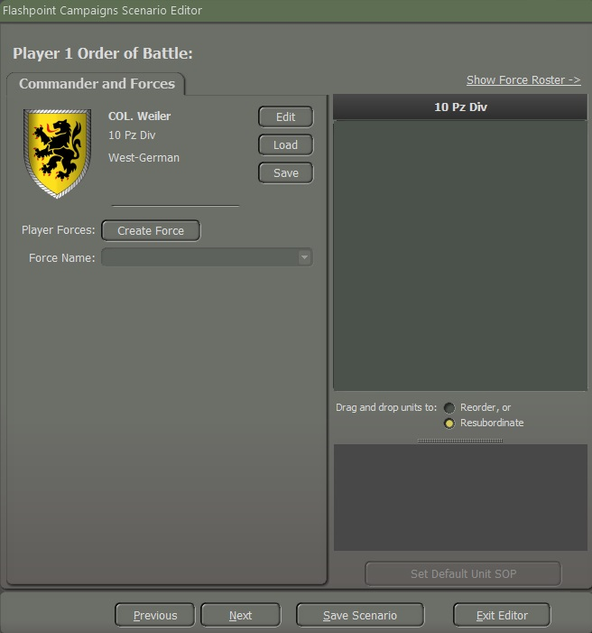

Figure

* **Edit** – Clicking on the “**Edit**” button will reopen the Commander Selection screen Figure 43 and allow you to change any of the information including the National Era if you want to adjust the lead nation.
* **Load** – Clicking the “**Load**” button will open the following dialog allowing you to select a Nation as seen in Figure 45.

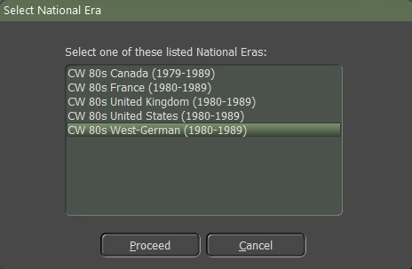

Figure

Click on the Leader you wish to load as shown in Figure 46, and then select the “**Proceed**” button.

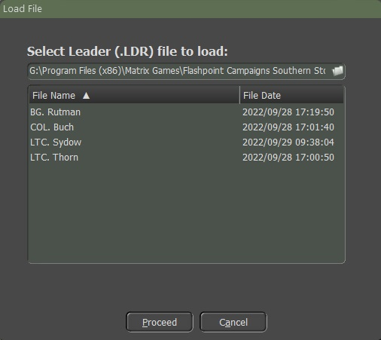

Figure

* **Save** – Clicking on the “Save” button will open the following popup dialog to allow you to save the current Leader setup to a file for use as shown in Figure 47.

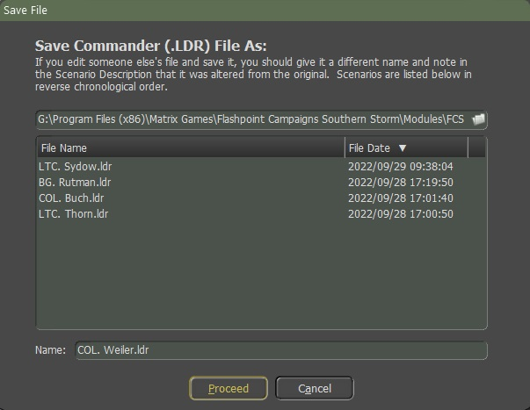

Figure

You can use the name as shown or enter your name for the file in the “Name” text box as shown in Figure 48. Click the “**Proceed**” button when you are ready to save the Leader information. As noted in the text, if you change an existing leader file, you will want to change the save name to avoid overwriting the original file.

### Creating a Force

In this section, we will guide you through the step-by-step procedure of constructing a force. This involves the incorporation of both “NATO” and “Warsaw Pact” forces into a designated scenario.

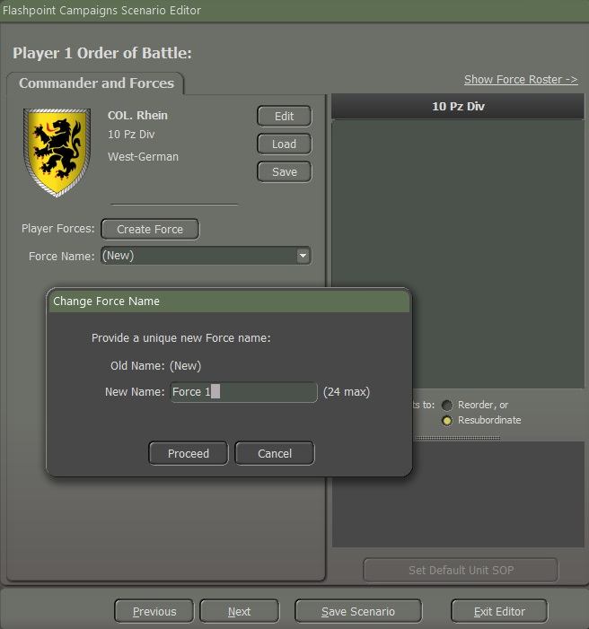

Figure

Once you have a Nation and Leader selected, it is time to add forces to side 1. Click the “**Create Force**” button and a Change Force Name dialog window will pop up as illustrated in Figure 49.

In the “New Name” field, name your force as illustrated in Figure 49, in this example, the name is “Force 1”.

The name should reflect what the selected force will be or do in the scenario. In most cases, you will be adding several forces to this side so having good names will help you organize.

Names must be unique and can be up to 24 characters in length. Once you have created a Name for the Force, click the “**Proceed**” button so that we can begin to add units.

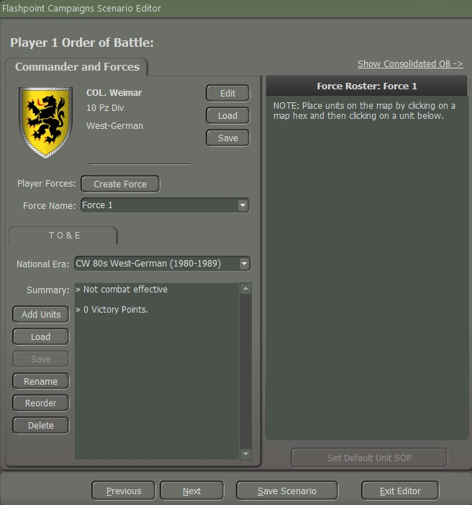

Figure

In the dropdown box, you can see and select any of the forces you have made for this side. This is useful if you need to edit forces after creating them.

The TO&E (Table of Organization and Equipment) tab is where you Add Units, load saved packages of units, save a package of units, Rename the current Force, or Delete the force from the scenario.

**NOTE:** Once you delete a force, there is no undoing it. Be sure you want to drop the entire force from the scenario.

After you click the “**Add Units**” button to open the Force Selection main dialog as illustrated in Figure 51.

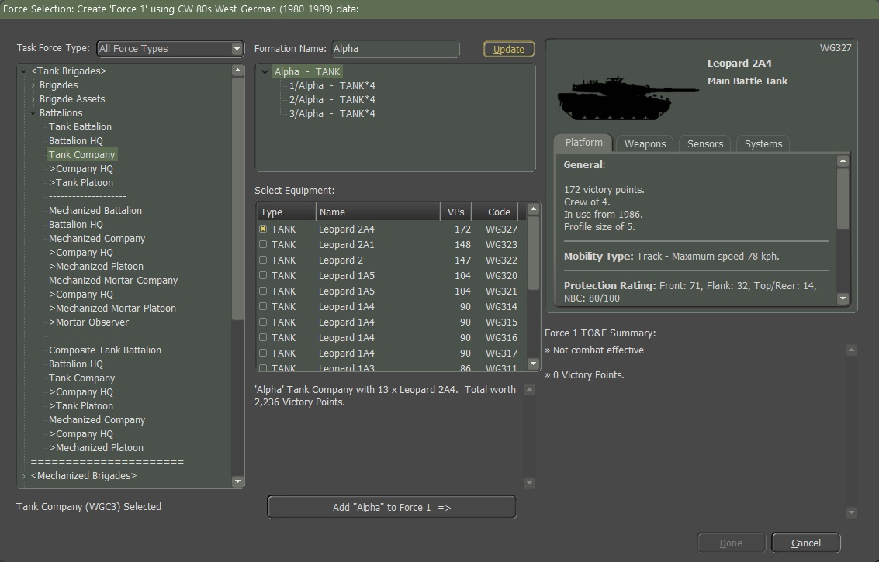

Figure

Starting from left to right, the first section (**1**) “Task Force Type” holds an expandable “Order of Battle” for the nation selected. You can expand a section by clicking on the right-facing chevron. You can collapse a section by clicking on a downward-facing chevron. The Battalions section has been highlighted and opened for viewing and selection.

When you click on an entry in this window, information is filled in in the other windows as shown above. In this case, a Tank Company has been selected.

The next section is the (**2**) Formation Name. Enter a name for the formation. In this case “Alpha”. These names are based on the historical narrative of the scenario.

Any name you enter in this text field will be updated through the formation when you click the Update button. If you do not enter a name and click the “**Update**” button, you will get a Confirm popup window as seen in Figure 52 asking “Are you sure” statement, if you click the “**Yes**” button it will have no name for the unit, if you click the “**No**” button you can then add the name of your choice.

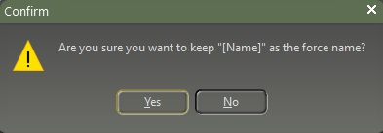

Figure

The second function is to see the breakdown of the selected formation from the (**3**) OOB tree.

This window allows for the selection of specific equipment based on the formation information seen in the window. All possible selections for the type of equipment are listed in the window. Select each type by checking the box for each type listed. In this case, the TANK the Leopard C2A4 is selected. The information is illustrated in Figure 53.

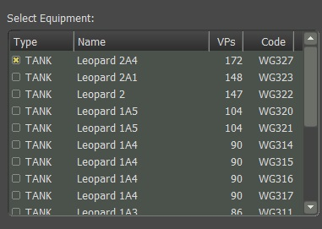

Figure

The fields in Figure 53 have the following meanings:

1. **Type** – These are the data types used to select units from the database seen in the formation descriptions in the window.
2. **Name** – This is the name of the unit type being selected.
3. **VPs** – This is the Victory Point cost (VPs) for the units. The higher the cost the more capable and expensive the platform is.
4. **Code** – The code is the alpha-numeric ID for the platform in the Units tab of the national database. The same ID can be seen in the upper right of the SUI window (**4**) as seen in Figure 54.

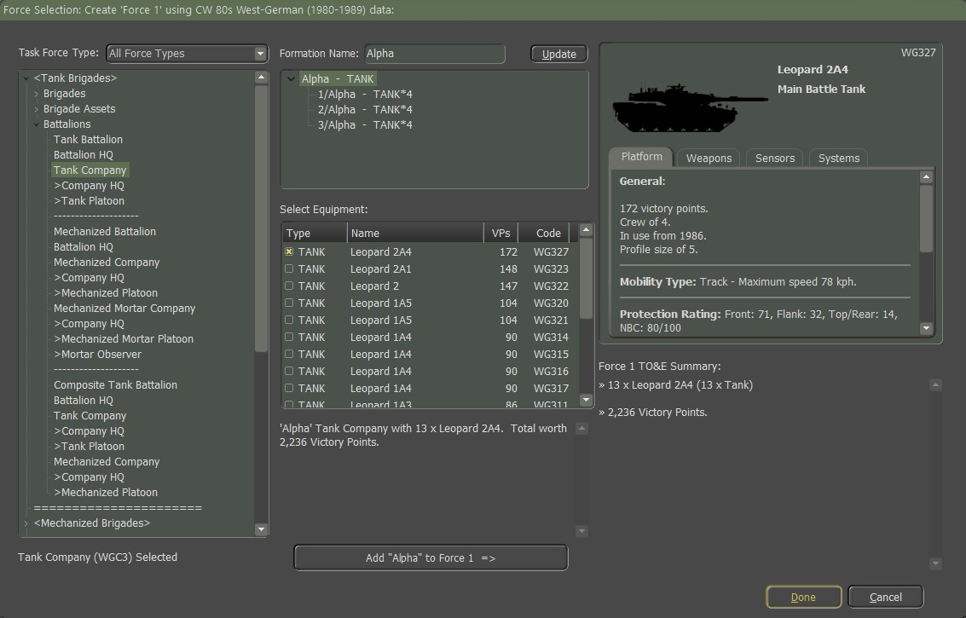

Figure

Once the Name is updated from (**2**) and the unit types are selected in (**3**), the text description of the formation is updated in this window for review. If this is the package you want to add to the Force (in this case “Force 1”), click the “**Add [formation name] to [force name] =>**” button. The results are shown in Figure 54.

Next is the Subunit Inspector (**4**) which can be used to review any of the units in the four-tabbed panel that covers the Platform, Weapons, Sensors, and Systems that the selected sub-unit has. Select Equipment area (**3**) by clicking on any of the entries. In this case, the “Leopard C2A4” was selected. The layout and information shown in the Subunit Inspector (SUI) can be found in the “**FM01: Game Operations, Section 14.3**” document.

In the final part of the window, **(5**) you will get a breakdown of all the elements in the noted force. In this case, Force 1 is shown in Figure 55.

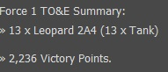

Figure

You also get a total for the lift available in the unit for passenger transport and then the total VP value of the force in its current layout. Once you’re done click on the “**Done**” button.

### Set Default Unit SOP

Once we created a Force they are in the Force Roster as illustrated in Figure 57. We want to start to work on the SOP.

SOPs (Standard Operating Procedures) are unit instructions on how to behave in certain situations on the battlefield. This menu item provides a means to adjust SOP characteristics for selected units or to set SOPs based on the type of unit and the selected SOP package for the selected units.

This tool gives you the flexibility to adjust many different operational parameters of your units, per unit, per waypoint, and for new orders. Grayed-out parameters are not available for the selected unit.

These SOPs can be applied to the selected unit or easily copied to other units in the formation or of a similar platform type.

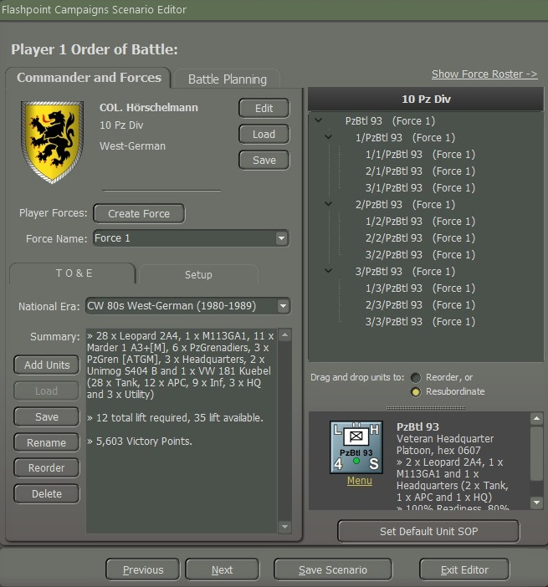

Figure

To do that we will highlight the Panzer Headquarters and select the “**menu**” under the icon and a popup screen will appear select “**SOP** **Manage**r” (Ctrl+k) as illustrated in Figure 57 or select the “**Set Default Unit SOP**” button as shown in Figure 56.

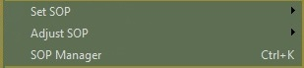

Figure

We will cover the “**Set SOP**” and “**Adjust SOP**” in more detail in the “**FM05: Battle Planner.**”

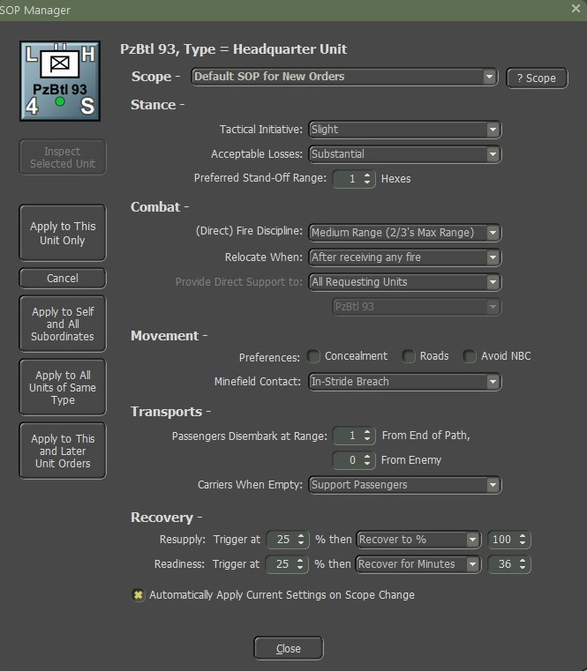

Figure

#### Scope

The Scope sets which order (new, current singular order like Screen or Hold, or per waypoint of a move) the settings are applied to.

Once all the settings are adjusted to the parameters you want for the unit(s) there are options on how to Apply them as noted in Subsection 4.5.2.7.

Selecting the **“? Scope**” button will pop up the following message providing information on how the Scope is used as shown in Figure 58.

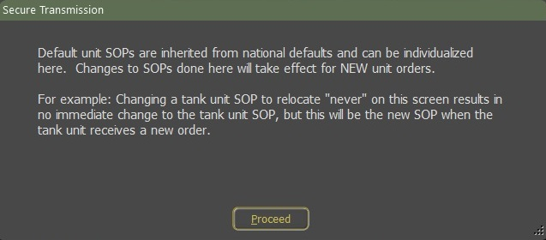

Figure

#### Stance

* **Tactical Initiative** – This is the likelihood of a unit deviating from its orders or pathing based on the current situation it is in (under fire, outnumbered, etc.). These settings are None, Slight, Moderate, or Generous.
* **Acceptable Losses** – This is the unit(s) willingness to take losses before seeking a change in orders. This works with the Tactical Initiative above to set how a unit reacts. The settings for this item are Do or Die, Substantial, Moderate, or Minimal.
* **Preferred Standoff Range** – The number of 500m hexes you wish the unit(s) to be distant from any detected enemy units.

#### Combat

* **Direct Fire Discipline** – This sets the range or ability to shoot at enemy units in direct fire. The available settings are Refuse fire, Hold until fired on, Point blank (0 to 1 hex), Short Range (1/3 Max Range), Medium Range (2/3 Max Range), and Maximum Range.
* **Relocate When** – This determines under what condition a unit will seek to scoot to a new location for better protection or to avoid enemy fire. The possible selections are After each fire mission, After all fire missions, While the enemy spotted, After receiving any fire, After receiving direct fire, After taking any losses, After taking direct fire losses, or Never. Some of these settings work better for certain types of units. The after-fire mission settings work better for artillery for instance.
* **Provide Direct Support to** – This setting is for Indirect Fire Units only and allows you to set specific direct support operations for your artillery assets. The default setting is support for All Requesting Units. Other options that support specific units are Units in the same formation or lower, Specified HQ or lower, or Refuse all requests (which stops the FSCC from using this unit in any supporting call for fires).

#### Movement

* **Preference**s – When a unit moves from waypoint to waypoint there are a few options for how that travel can be done. The hasty move will prefer roads, and Deliberate or Assaulting move orders will mix roads with cross-country movement. You can set stricter movement preferences by checking the boxes for Concealment (more off-road and seeking better-covered terrain to move through, Roads (favor taking roads instead of cross country), and Avoid NBC (which will path units around NBC-contaminated locations on the map).
* **Minefield Contact** – This is the unit(s) response to entering a minefield. The options here are Ignore and Run (do not delay and accept the potential for more subunit losses crossing the field), In Stride Breach (units slow down to follow a leader through the field hoping to avoid mines by traveling in the same tracks), or Stop and Reduce (units halt and either wait for engineers to remove enough mines to open a path through or do the work themselves at a slower rate).

#### Transports

* **Passengers Disembark at Range** – There are two options for disembarking transported troops and teams from their carriers. The first option is setting a few hexes (500m) from the final waypoint. This is useful for assaults or recon efforts in hostile territory. The other option is setting a few hexes from a spotted enemy. This is useful if on the move and your troops encounter unexpected enemy contact.
* **Carriers when Empty** – Once transporting APCs (Armored Personnel Carriers) or IFVs (Infantry Fighting Vehicles) disembark their troops or teams, this setting tells the transporting units what they should do. For APCs, the better choice is to Hide Nearby (seek cover and do not engage the enemy) as these vehicles are usually poorly armed and armored. The other option is to Support Passengers (seek good cover but engage enemy units with on-board weapon systems) to improve firepower against the enemy, but risks losing transports to enemy fire.

#### Recovery

* **Resupply** – This option lets you set a limit for the unit’s Ammo level. When it hits the trigger level or below, the unit will go into resupply until it either Recovers to the set percentage over time or recovers for a set amount of time which restores an amount of ammo based on the amount of time set.
* **Readiness** – This option lets you set a limit for the unit’s Readiness level. When it hits the trigger level or below, the units will go into resupply until it either Recovers to the set percentage over time or recovers for a set amount of time which restores an amount of readiness based on the amount of time set.

#### Inspect and Apply

There are six buttons on the left as shown in Figure 58.

1. **Inspect Selected Unit** – If you want to select and see the SOPs for another unit on the map, select a new unit on the map and then click the Inspect Selected Unit button to have the SOP Manager display its SOP values.
2. **Apply to This Unit Only** – This applies all the changes made only to the selected unit.
3. **Cancel** – Restores the original SOP values before any changes are made. Once You do an Apply, there is no way to revert changes via this option.
4. **Apply to Self and All Subordinates** – This setting is helpful if you want to set all the units in a formation (HQ and subordinates). The higher the HQ, the more units will be changed down the order of battle chain. When applied a dialog will pop up showing all the affected units.
5. **Apply to All Units of the Same Type** – This setting is useful if you want to set all the units of a selected type (like Tanks, APCs, HQs, etc.). When applied a dialog will pop up showing all the affected units.
6. **Apply to This and Later Unit Orders** – This option allows you to take the current SOP setting and apply it to all the orders in the Scope list.

At the bottom of the dialog is a check box to Automatically Apply Current Settings on the Scope Change. If this is active, any changes that are applied to the indicated scope will apply if you select a new unit and click the Inspect Selected Unit button. With it active if you switch to a new order in the scope selection, any changes will be applied to the previous order scope.

### Adding to an Existing Force

After clicking on the “**Done**” button you will return to the Player 1 Order of Battle, and you realize that you want to add an existing force to Force 1 so that they will be operating together on the battlefield. You should take care not to mix units of different functionalities in a Force. For example, add recon to a tank or mechanized Force. The game will not allow air and helicopter units to mix with ground units, nor can air and helicopter be mixed. The idea is to have different Forces based on mission-focused capability. You will need to split larger formations into discreet forces so the AI can utilize them correctly and Battle Plans can be constructed for those Forces properly.

To add more units to the existing force we need to take the following steps.

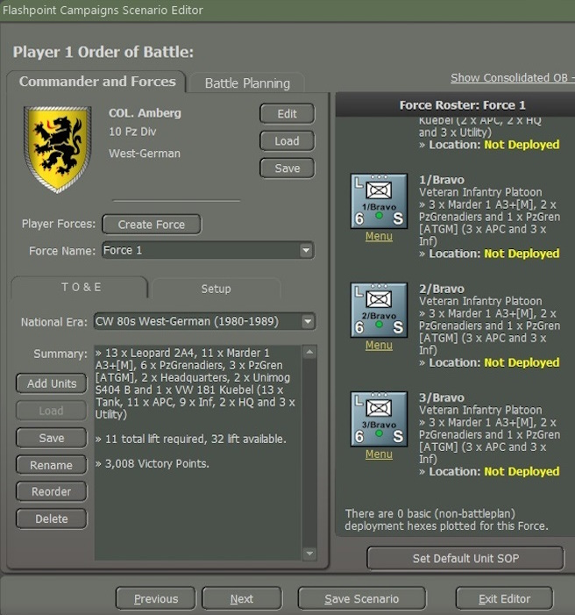

Figure

1. Make sure to select the correct force you wish to add more units to from the dropdown box, in this case, it will be “Force 1”.
2. Click the “**Add Units**” button to open the Force Selection screen.
3. Choose the formation, name, and subunit selections as noted above. In this case, we are selecting a Mechanized Platoon which we will label as” Bravo” to add to Force 1 as illustrated in Figure 61.

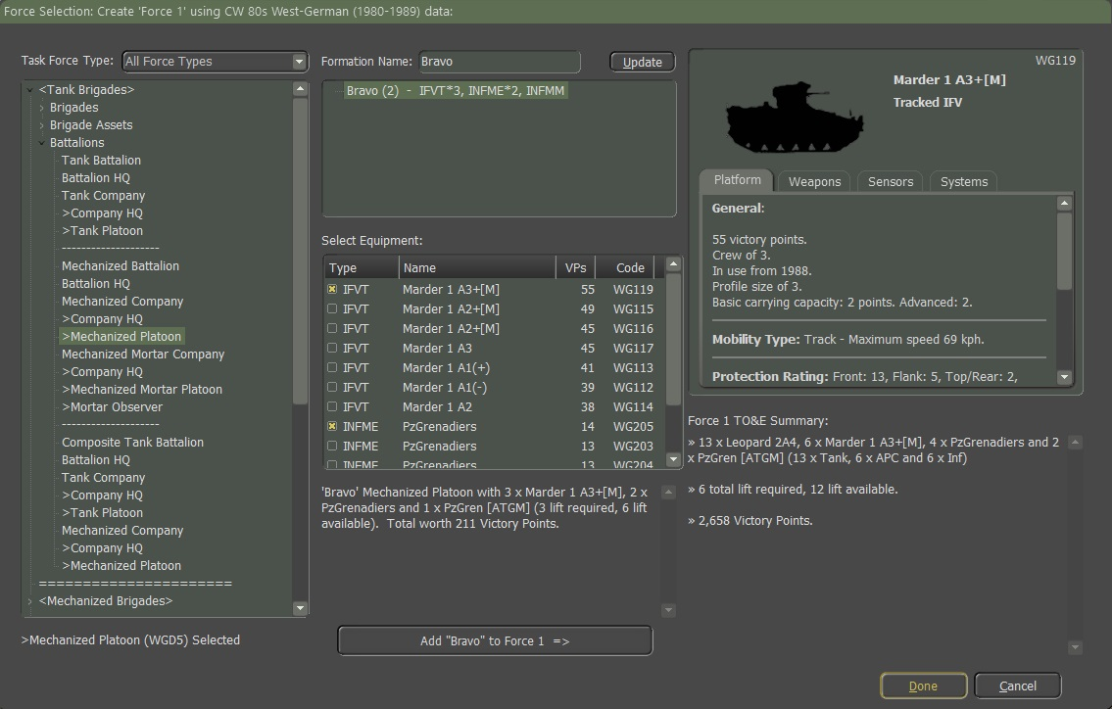

Figure

1. After clicking the “**Add Bravo to Force** **1**” button, you should have the updated TO&E summary in the window. This will note the VP cost total and the Lift for passengers in the force as shown in Figure 62.

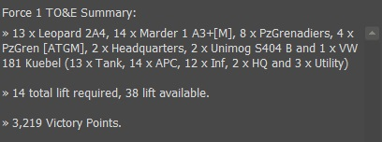

Figure

Click the “**Done**” button to return to the Scenario editor dialog and close the Force Selection screen.

### Creating Additional Forces

We are going to create additional forces to the forces to side 1. First, we Click the “**Create**” Force button and a Change Force Name dialog window will pop up as shown above.

In the New Name field, name your force, in this example, the name is going to be “Force 2” as illustrated in Figure 63.

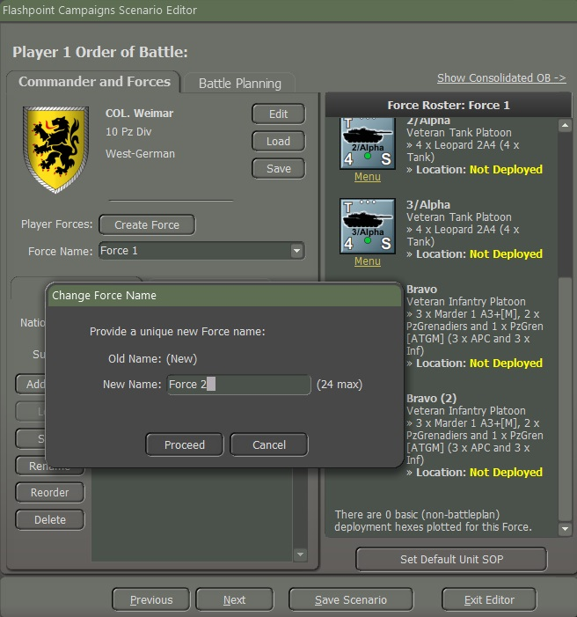

Figure

Once we have labeled the additional Force Name, then click on the “**Proceed**” button.

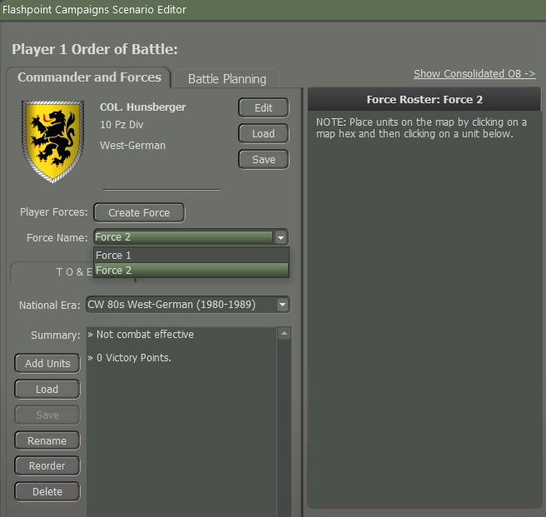

Figure

Here you will see that there are two Forces, Force 1 and now Force 2. Force 2 is highlighted as illustrated in Figure 64, and we will start to add units to Force 2 as we did for Force 1 in “**Section 4.5.1, Creating a Force**”.

### Saving a Force



Figure

To save a Force, make sure that the Force Name is selected for the Force that you want to save as illustrated in Figure 65. Click on the “**Save**” button and a popup window screen as shown in Figure 66. Make sure that this is the Force you want to save, for this example, we will save “Force 1”. Click on the “**Proceed**” button to save the file.

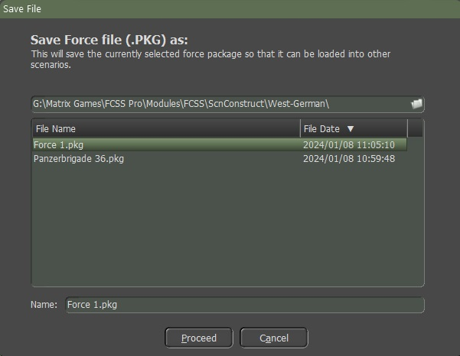

Figure

It will be saved as a .pkg file in the FCSS\Modules\FCSS\ScnConstruct\West German folder.

### Loading a Force

To load a saved National Force, it must be from the same country that it was saved from. For example, if you saved the National Force Package from West Germany and you try to load it to a British scenario it won’t work. It will be blank as shown in Figure 67. So, to load a German saved force the National Era must be West German as shown in Figure 68, if you want to load a West German force onto a British-made Scenario.

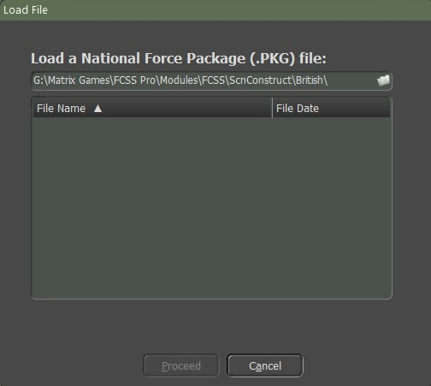

Figure

You must create a new Force Name, for this example, we will call it “Force 3”, you need to go to the “National Era” dropdown box and select “West German” by highlighting it as illustrated in Figure 68.

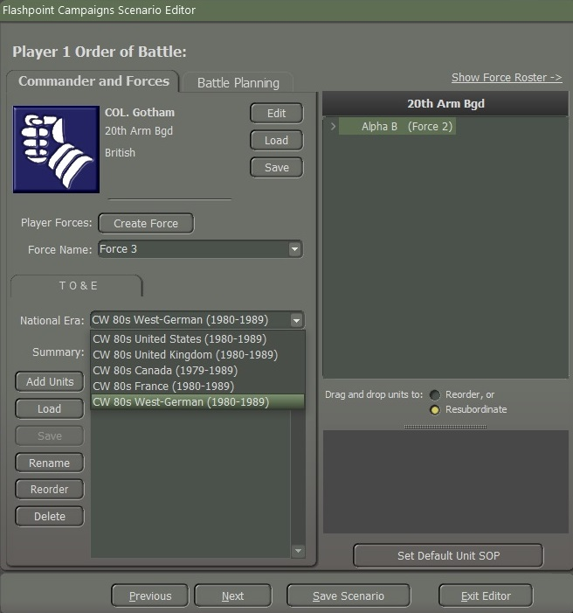

Figure

Select the “**Load**” button and you will get a pop-up “Load a National Force Package file” screen as illustrated in Figure 68.

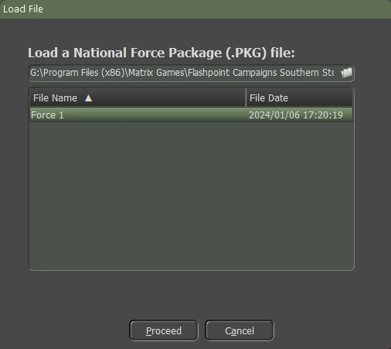

Figure

Highlight the file you want to load; in this case, it will be “Force 1”. Select the “**Proceed**” button as shown in Figure 69.

You must highlight the Force that you want to load as illustrated in Figure 69. If you do not highlight the force and click the “**Proceed**” button, you will get an error as shown in Figure 70. Click the “**Okay**” button and then highlight the force to load.

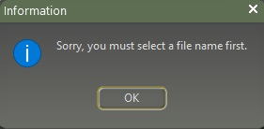

Figure

If you highlight the force to load you will get another screen that will pop up “Secure Transmission Regarding PzBtl 23 as shown in Figure 71. Here we can give a unit a unique name if we choose to.

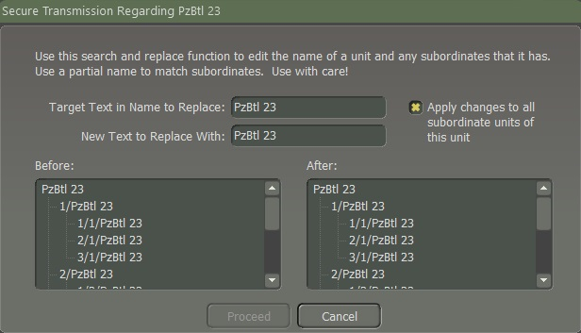

Figure

Here you can edit the name of a unit and any subordinate units. What we are going to do is replace the unit’s name from (**1**) “PzBtl 23” to (**2**) “PzBtl 30” as illustrated in Figure 72. The (**3**) “Before” section has the old unit’s name while the (**4**) “After” section has the new name of the unit, then select the “**Proceed**” button.

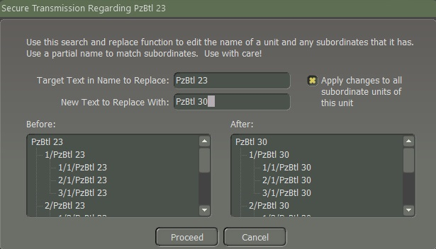

Figure

If you do not want the subordinate units’ names to be changed, unselect the (**5**) “Apply changes to all subordinate units of this unit” as shown in Figure 72. Then when finished, click on the “**Proceed**” button.

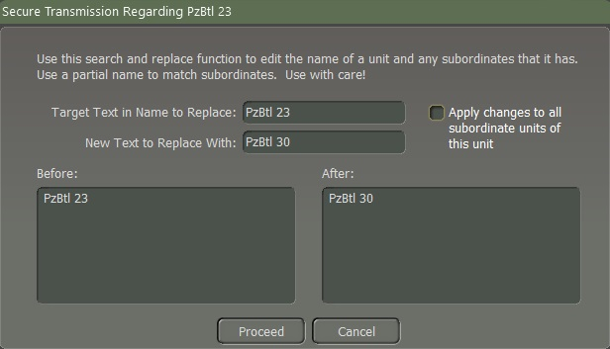

Figure

If you do not want to change any names to any unit select the “**Cancel**” button and the Force will load.

Here you can see that the West German Force 3 is showing in the OOB Tree along with the British Force 2 even when the save Force file is labeled as Force 1 it will update the Force to what you labeled it when naming the Force Name as shown in Figure 74.

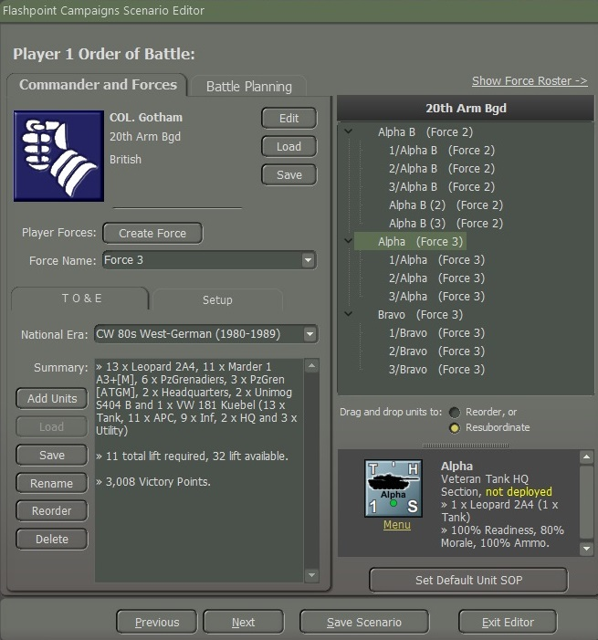

Figure

### Deleting a Force



Figure

To delete a Force, make sure you have the correct Force name in the “Force Name” drop-down and click on the “**Delete**” button and every unit in that Force will be deleted as shown in Figure 75.

You must make sure that this is what you want to do because once you delete a force it is gone for good unless you saved the Force file before deleting it.

### Renaming a Force



Figure

To rename a Force Name and keep all the units associated with it you can click on the “**Rename**” button as shown in Figure 76, and a “Change Force Name” dialog window will pop up as seen in Figure 77.

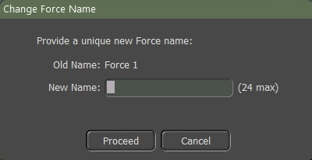

Figure

Type what you want it to be in the New Name box which can be up to 24 characters max and then click on the “**Proceed**” button and the new Force Name will replace the old Force Name.

### Reorder Forces



Figure

To Reorder the forces in the OOB Tree click on the “**Reorder**” button as shown in Figure 78 and a “Reorder Forces” dialog window will pop up as in Figure 79.

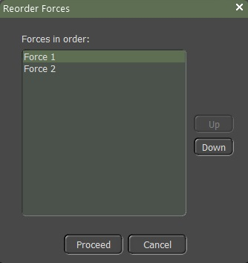

Figure

To Reorder a Force unit in the OOB Tree, first, highlight the unit for example “Force 1” and then use the “**Down**” button to move it down or if you want Force 2 before Force 1 just highlight it and then click on the “**Up**” button. Once you are done then click the “**Proceed**” button as shown in Figure 79.

There are two other ways to Reorder Forces. The first way of doing that is we need to have the OOB Tree in (**1**) Consolidated OB mode. When you switch to Consolidate mode the (**2**) “Drag and drop units to” Reorder or resubordinate units will appear as shown in Figure 80.

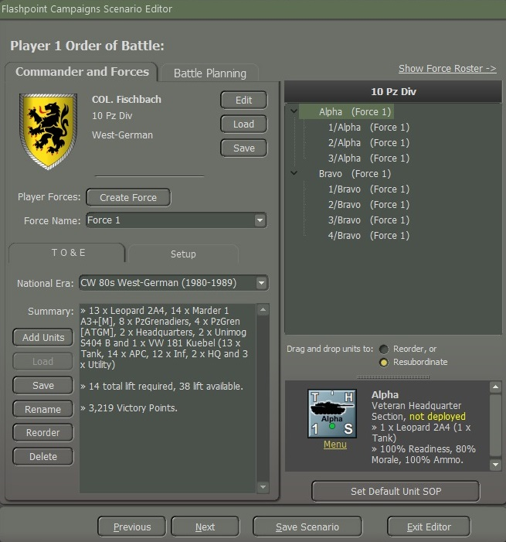

Figure

Let’s talk about the Resubordinate unit first, to move a unit for example, if we want to move (**1**) “3/Bravo” from his parent unit to another parent unit which is called “Attach” we must select the button (**2**) “**Resubordinate**”. To do that we must first highlight the unit “3/Bravo” left click on the unit and drag it up to the unit that is highlighted as illustrated in Figure 81, and it will be attached to the unit.

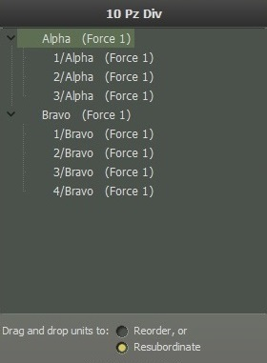

Figure

Now “3/Bravo” a Mech Plt” is attached to “Alpha Company” a Panzer Company as shown in Figure 82.

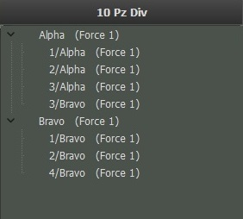

Figure

The next way to “Reorder” a unit is by selecting the (**1**) “**Reorder**” button. The “Reorder” unit is only for moving the unit within the parent company, for example, we want to move (**2**) “3/Bravo” to the top of the Bravo Company order as illustrated in Figure 83.

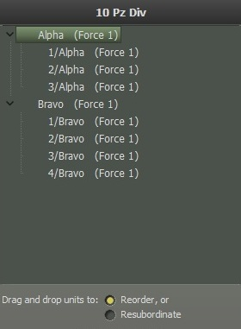

Figure

To do that we must highlight (**1**) “3/Bravo” and left click and drag to (**2**) “Bravo” company so that it will be on the top of the order as shown in Figure 84.

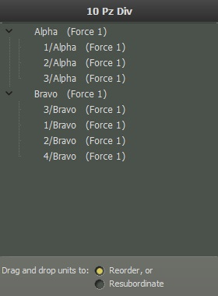

Figure

The principle is the same if you want to move Forces or just units.

## Show Consolidated Order of Battle (OOB)

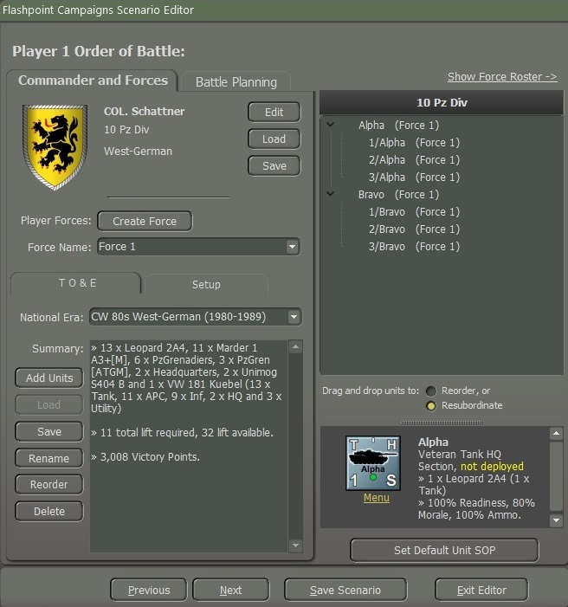

Figure

The screenshot that is displayed in Figure 85 shows a (**1**) “Consolidated OOB” to show a (**2**) “Force Roster” select the link.

## Show Force Roster



Figure

The screenshot that is displayed in Figure 86 shows a (**1**) “Force Roster” to show a (**2**) “Consolidated OOB” select the link.

## Deploying Forces on the Map

After creating forces for both sides, we must place the units on the map. Each task force must have a designated setup area on the map where it will start the game. The first step will be setting up the deployment zones and then placing the units on the map.

**NOTE:** This would be a good time to set your unit’s SOPs, for a good example see **FM03: Tutorial Operations** and **FM05: Battle Planner.**

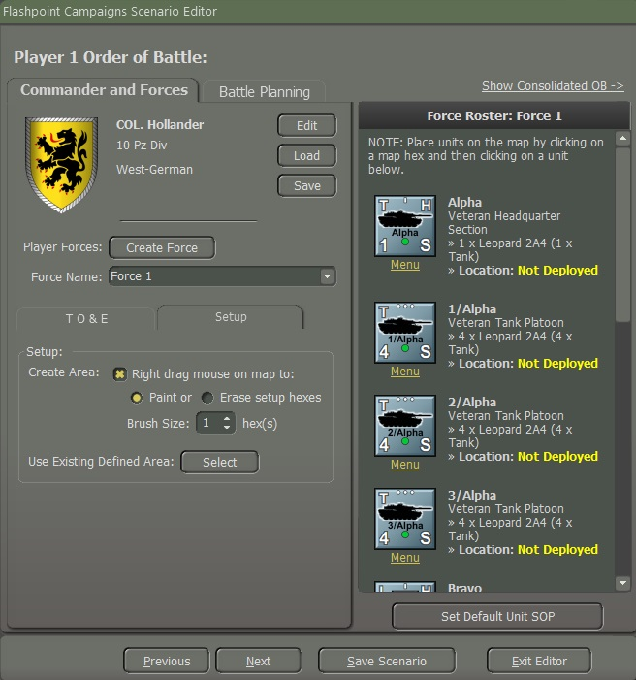

Figure

Looking at Figure 87, we must select the “Setup” tab then we will start by Creating an Area on the map by selecting (**1**) “Right drag the mouse on the map to”: (**2**) Paint. You can create individual hexes by just right-clicking on the map or right-clicking, holding, and dragging the cursor to create a large area on the map. If you need to erase a setup zone, select the (**3**) “Erase setup hexes” and right-click on the hex.

If you need to paint a larger area on the map you can increase the size of the brush by using the (**4**) “Brush Size” up and down arrows. The size of the brush can be only 1 - 9.

Another way of placing a unit on the map without going to the Setup Tab is by just left-clicking on the map and then left-clicking on the unit in the Tab Force Roster.

The last way to create setup zones for your units is if you have a setup zone already created for a force(s), you can open the dialog and select them for a new unit or force. It saves time setting things up or shifting things around when making Battle Plans and to do that, open (**5**) “Use Existing Defined Area” and select them for a new unit or force. To do that click the “**Select**” button as shown in Figure 87 which will cause a popup window screen as shown in Figure 88. The list of the setups by the Forces you created will be displayed in the “Select an area to use” box as shown in Figure 88. Next, click on the “**Save List**” button as shown in Figure 88.

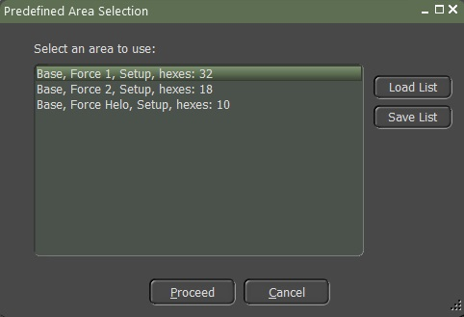

Figure

A popup window “Save a Predefined Areas File”, Figure 89, to save a predefined zone is that the file is saved with the name you type in the “File Name” box. For this example, I saved them as the Force Name as illustrated in Figure 89.

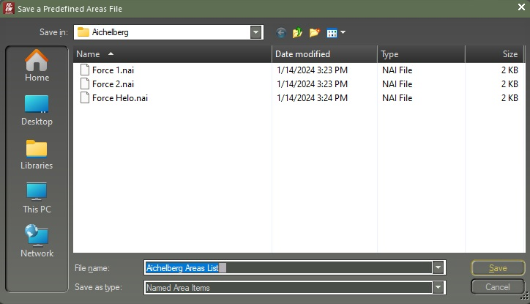

Figure

The saved files will be in the map folder, for example, this will be in the “Aichelberg” folder as shown in Figure 90.

. 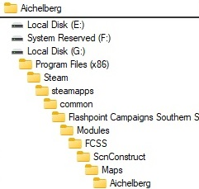

Figure

So, to put this in use, I want to add a Force 1 setup zone for another Force to use. I have created a new Force Name labeled “Force 3”. I added the units but did not place them on the map. To do that I must make sure that I have Force 3 in the “Force Name” drop-down box. Then bring up the “Predefined Area Selection” window. Highlight (**1**) Force 1 then select (**2**) the “Proceed” button as illustrated in Figure 91. Force 3 now has Force 1 setup zones.



Figure

Once Force 3 has Force 1 set up zones on the map, to keep them for Force 3, you must then save it by clicking the “**Save List**” button and saving the file as shown in Figure 91.

### Placing Units on the Map

The units you place on the map will be the setup that the player’s aide forces will be shown when a player starts the scenario. To initiate the deployment of a unit, first, select the desired hex on the map by clicking on it. Subsequently, click on the corresponding unit in the Force Roster as seen in Figure 92.

The selected hex will be incorporated into the Force setup zone, and the unit will be deployed in that location as shown in Figure 92.

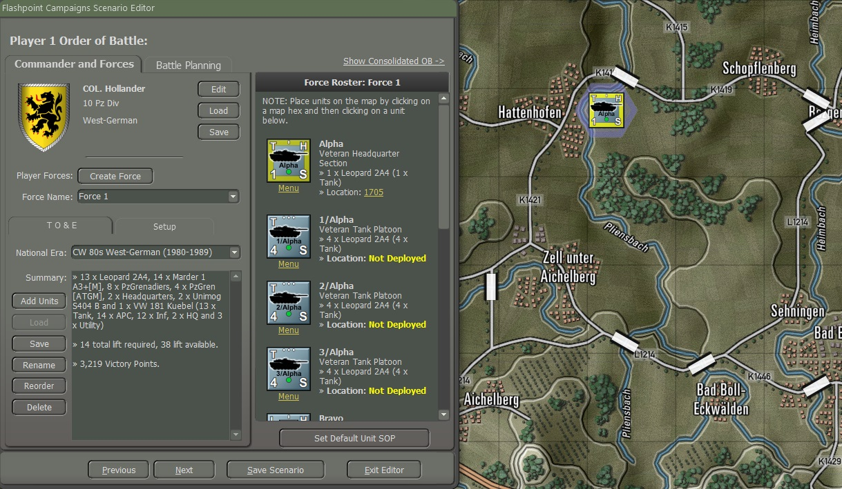

Figure

If you need to move the unit that you place left-click and drag the unit icon to a different location on the map.

Once you place a unit on the map and you need to find the location of a unit you click on the (**1**) hex number and the hex will flash for a few seconds to show the location as shown in Figure 93.

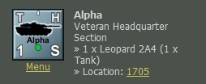

Figure

If you place units on the map and decide to remove them from the map, select the (**1**) Menu that is under the icon as shown in Figure 94 will cause a popup window as shown in Figure 95. Select the (**1**) Reset Location to “Not Deployed” as shown in Figure 95.

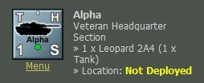

Figure

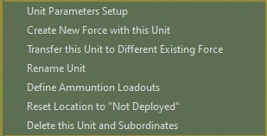

Figure

It will place the unit back in the Force Roster as (**2**) “Not Deployed” as shown in Figure 94.

### Deploying Units on and off Map

You are demonstrating the process of deploying artillery and air units on and off the map. We’re going to start with Artillery and Air units off the map and then show placing air units (helicopters) on the map. If you wish to deploy a unit off the map, there are two methods. The first involves placing a unit on the map and then deciding to deploy it off the map. To do this, right-click on the unit, and a popup screen will appear.

The second method is to select the “Menu” below the unit as illustrated in Figure 94.

Choose option (2) "Set Location to Off-map and Edit Distance Away," as illustrated in Figure 96.

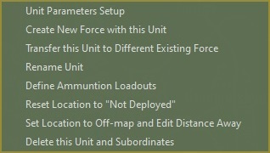

Figure

Once you select “Set Location to 0ff-map and Edit Distance Away", a popup screen is shown in Figure 97.

#### Deploying off-map Artillery Support

If Artillery units are placed on the map, it might be visible to the enemy, making it vulnerable to counterattacks. On the other hand, keeping artillery off-map can provide the element of surprise, allowing for strategic positioning and minimizing the risk of immediate detection.

Before beginning to set the unit distance from the center of the map, we want to show the range coverage that the unit selected can cover on the map.

Select (**1**) “Show Range Coverage on Map” to display the range ring as shown in Figure 97.

Top of Figure 97 is information (**2**) on the size of the map, unit name, and maximum range.

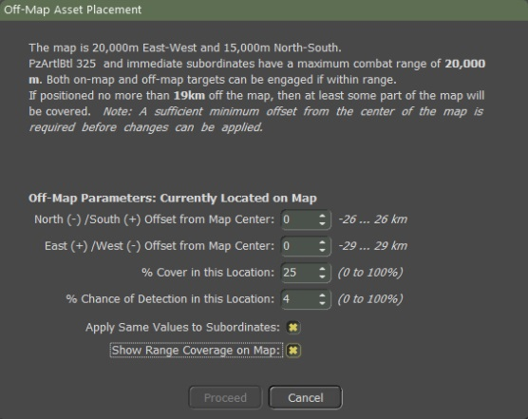

Figure

When you have, for example, an Artillery Battalion and you want all the units to be included with the battalion headquarters to be in the same location you need to select (**7)** “Apply Same Values to Subordinates”.

Figure 98 illustrates the range circle of the artillery unit on the map when you activate the (**1**) "Show Range Coverage on Map" option.

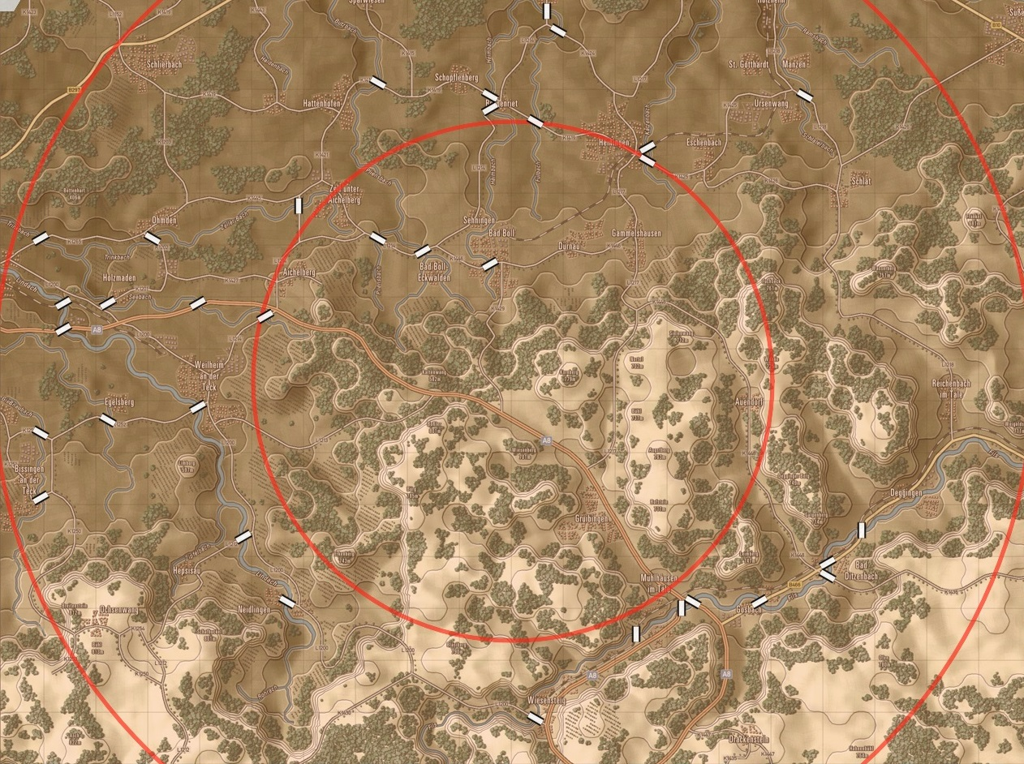

Figure

To move the center of the unit (**3**) North (-) or South (+) offset from Map Center use the up/down arrows (-26 … 26km)

To move the center of the unit (**4**) East (+) or West (-) offset from Map Center use the up/down arrows (-29 … 29km)

In this instance, I relocated the unit's center to the west by 3 kilometers from the nearest edge of the map. Refer to Figure 99 for an illustration of the unit's position on the map and its coverage.

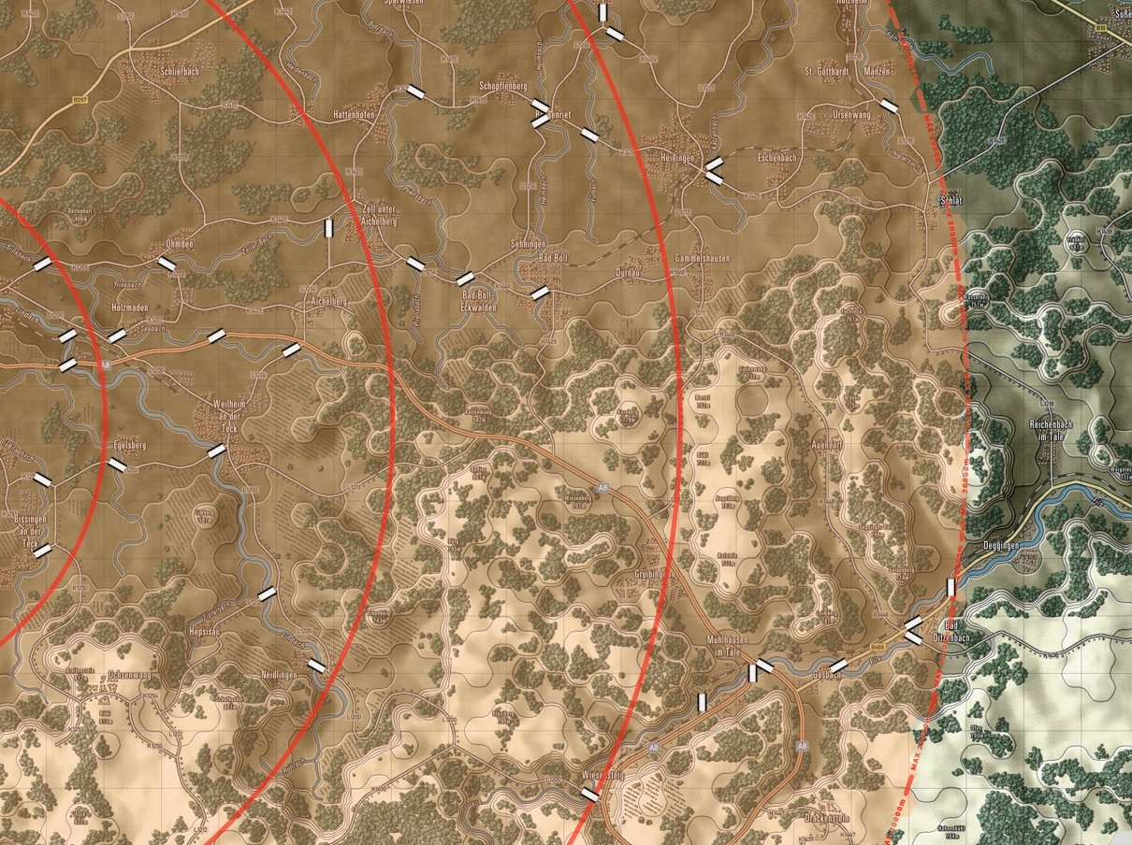

Figure

The (**5**) % Cover in this Location indicates the amount of cover the unit has per terrain. Currently, it doesn't have any impact on off-map units, but it will be soon. It is suggested to leave it as is for now, which is 25 by default.

As (**6**) Chance of Detection in this Location, represents the likelihood of an artillery unit being detected by counter-battery radar each time it fires a round. It is recommended a value of around 4%, which seems appropriate. However, it is advised against adjusting it to less than 3% or more than 5%. It is recommended that players refrain from changing the default values currently.

When all is done the unit displayed in the OOB Tree will show how far the unit is from the edge of the map as illustrated in Figure 100.

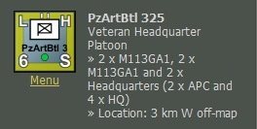

Figure

#### Deploying off-map Air Support

Off-Map Air Support comprises various types of propeller or jet-powered aircraft with diverse missions aimed at engaging targets on the battlefield. There are Strike, SEAD, Recon, and Utility versions of aircraft. These aircraft remain off the map, specifically in designated loiter areas until they are directed by the player or FSCC (Fire Support Coordination Center) for air strikes. Upon completing the air strike, surviving aircraft either return to base for rearming if out of ammunition or resume station if weapons are still available. Following rearming, they await future assignments by returning to the loiter area.

When deploying units off map they cannot be mixed, Aircraft and Helicopters in the same Force a popup screen as shown in Figure 191 will appear. Click the “**OK**” button.

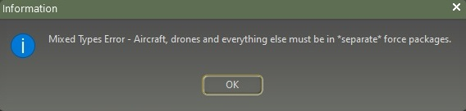

Figure

Create a new force as shown in **Section 4.5.1 Creating a Force.** For this example, we will create a Force labeled “Air”.

Add Units for which we will select “Air Support”, “Aircraft”, “Aircraft Section”, and “Strike Aircraft Section” as illustrated in Figure 102.

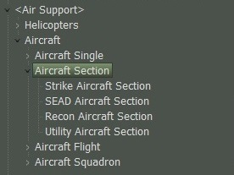

Figure

Aircraft cannot be placed straight onto the map, you must select “Menu” located underneath the icon. Select “**Set Location to Off-map and Edit Distance Away**”. A screen will pop up as shown in Figure 103. You can position up to 250km offset from the map edge. As seen in Figure 103 the default is set for **(1**) 90km from the nearest map edge. You adjust the (**2**) Offset from Map Center. You do not need to do anything to the (**3**) Cover or Chance. Nor (**4**) Show Range Coverage on the Map is not needed for Aircraft.

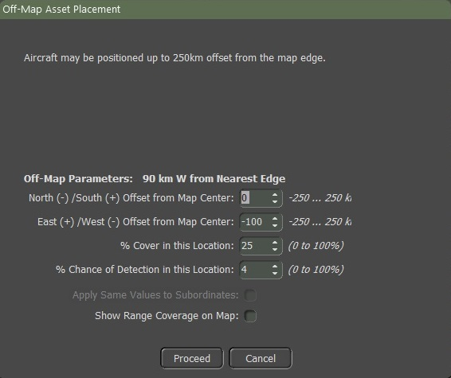

Figure

#### Deploying on-map Air Support

On-Map Air Support comprises various types of helicopters that are included in the game. There are Attack, Scout, and Utility versions of Helicopters. Helicopters can carry a variety of weapons geared to anti-armor or anti-personnel missions, but they can also be assigned to perform reconnaissance tasks. On-map helicopter support is directed by the player.

The Forward Arming and Refueling Point (FARP) unit is used as the base for all helicopters. This unit acts as the high HQ for helicopter operations and is the location to send your helicopters back for rearming and resting during a battle. If the FARP is missing/destroyed, then the unit will go to the current highest HQ on the map to resupply.

Depending on movement orders, helicopters will fly Nap of the Earth (NOP) using terrain to screen and cover their movements when in Hunt Move or doing a Deliberate Move. They will fly at low altitude if executing a hasty move.

Click on the “**Add Units**” button for which we will select “Air Support”, “Helicopters”, “Helicopters Section”, and “Attack Helicopters Section” as illustrated in Figure 104.

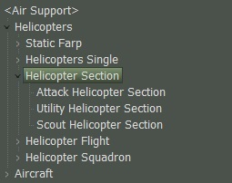

Figure

For this example, we will select two Attack Helicopter Sections and resubordinate them to FARP 1 as shown in Figure 105.

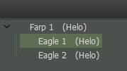

Figure

1. Eagle 1 is set to arrive around twenty minutes.
2. Eagle 2 will start on the map.
3. If they need to resupply, they will move to FARP 1.

As illustrated in Figure 106.

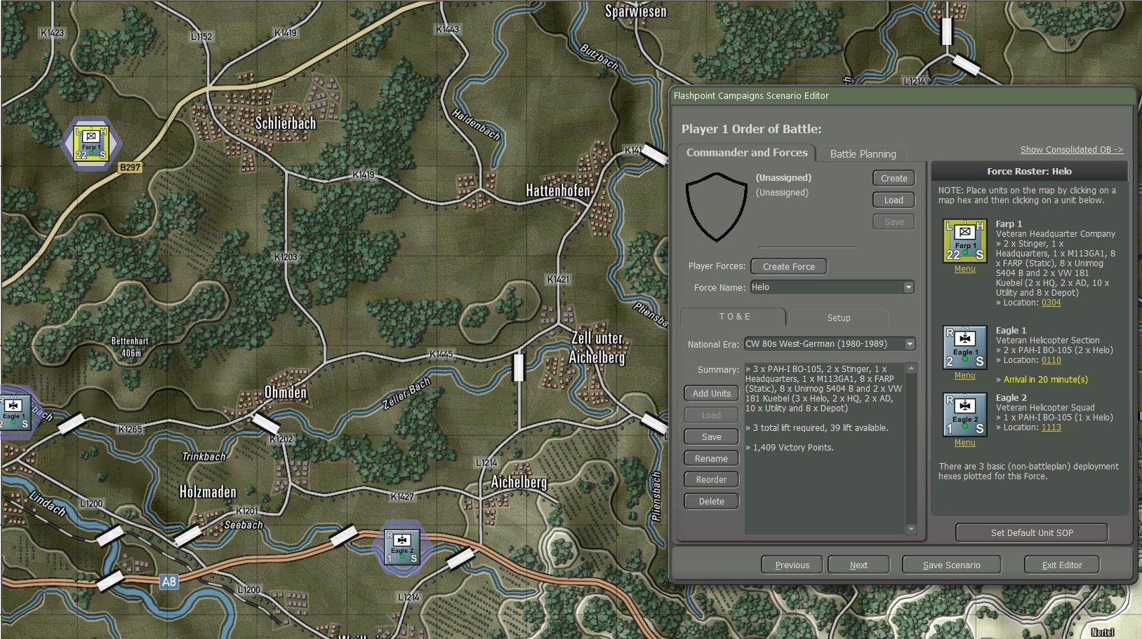

Figure

#### Deploying Reinforcements

Deploying reinforcements adds a layer of complexity to war games, requiring players to make strategic decisions that can have a significant impact on the outcome of battles.

Reinforcements are typically used to strengthen a position, counter an enemy threat, or support existing troops.

We’re going to show how to place units on a map as reinforcements.

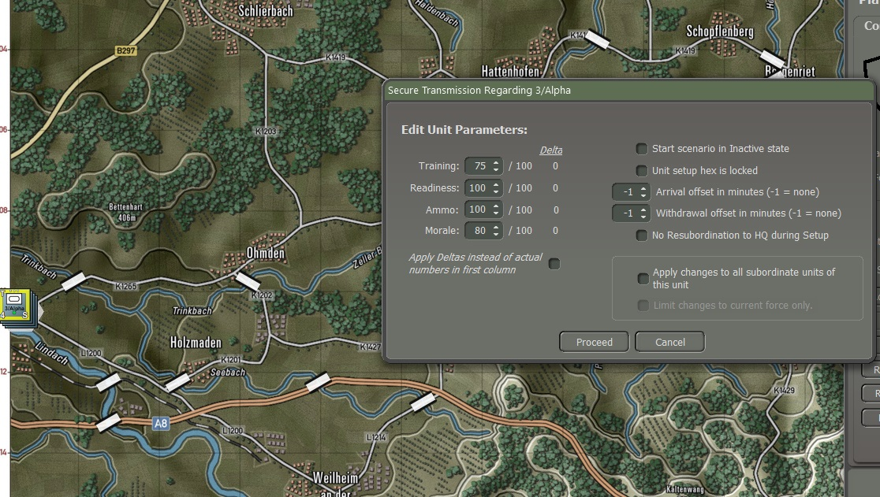

Figure

For this example, we will place the West German Panzer company units on the west edge of the map as illustrated in Figure 107. Right-click on the unit and select “Unit Parameters Setup” a popup screen as shown in Figure 108.

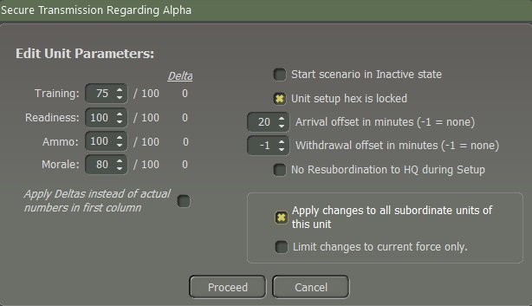

Figure

1. To set the time for the arrival of reinforcements by using the up/down arrows in minutes, for this example it is set for 30 minutes for the arrival of the units.
2. By selecting “Apply to all subordinate units of this unit” will apply to all the Panzer units in the company as shown in Figure 105.
3. The local Force is the Force Package you are currently working on.  Say you have 3 packages, each of a Leopard 2A4 tank company.  If you edit the tanks in one of the companies, you can have those same edits apply to the other two force packages of tanks or not using this checkbox.  The thought is that you will want to distinguish between them at times and this saves a lot of clicking later.
4. By selecting the “Unit setup hex is locked” the units are locked in that hex and players cannot move the units to another hex.

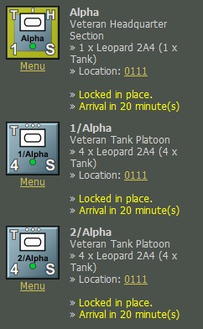

Figure

### Ammunition Loadout

After creating your forces, you may need or want to make changes to the ammo loadout to your units. First, select “Menu” which is located under the unit icon. To do that you open the Unit Dashboard and select “**Define Ammunitions Loadout**” as shown in Figure 110.

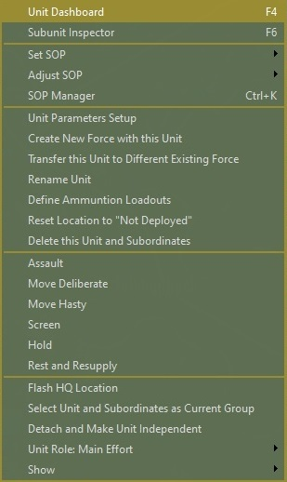

Figure

When you select “Define Ammunition Loadouts” a popup screen is shown in Figure 111. For this example, we will look at a tank platoon, 1/2/PzBtl 244 as shown at the top of Figure 111.

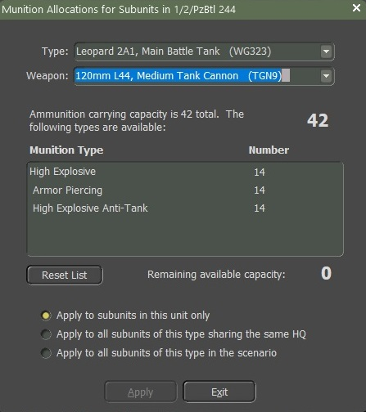

Figure

1. Type: List the type of equipment and/or personnel. Use the drop-down arrow to display a list of all the equipment for that platoon as shown in Figure 112.

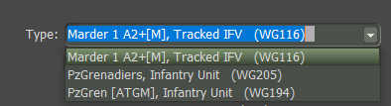

Figure

1. Weapon: List all the weapons that are in the Platoon as shown in Figure 113. Use the drop-down arrow to display a list of all the equipment for that platoon.

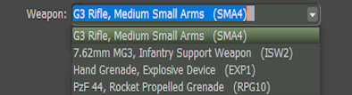

Figure

1. Ammunition carrying capacity for this example is 42 total for the selected weapon as shown in Figure 114.

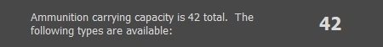

Figure

1. Munition Type: This is a list of the type of ammo that this unit is carrying as shown in Figure 115.

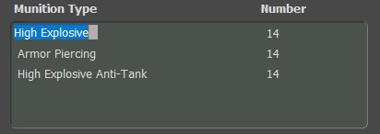

Figure

1. We know that the total amount of ammo for this Leopard 2A1 is 42. But I want to change the amount of ammo for, for example, I want to remove the High Explosive Anti-Tank rounds from 14 to 0. To do that you must highlight the type of ammo and then highlight the number of rounds in this case 14. Using the drop-down arrows, you can make the changes. I elected to reduce it to 0. When doing so the “Remaining available capacity will change from 0 to 14 as shown in Figure 116. Select the ammo on which you want to add and then select the number of rounds and up and down arrows which will add the amount of ammo and the remaining available capacity will change.

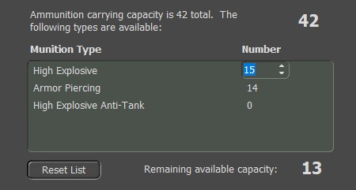

Figure

1. “Reset List” button, select the button, if you decide to reset the ammo amount back to the default. When you select the button a popup screen to confirm. Select the “Yes” button and it will reset to default. If you select the “No” button there will be no update to default as shown in Figure 117.

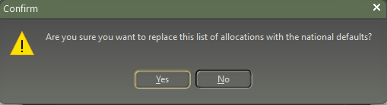

Figure

1. Apply is self-explanatory, how you want to apply the changes to this unit, the same type, or all units of this type.

Once you have completed the changes select the “**Apply**” button and then the “Exit” button.

### Default Deployment Zones

After Section 4.8 Deploying Forces on the Map, you can set up default zones. Figure 118 shows a highlighted unit with just a single setup. If you try to move the unit to a different location on the map you will get a popup on the map as shown in Figure 119.

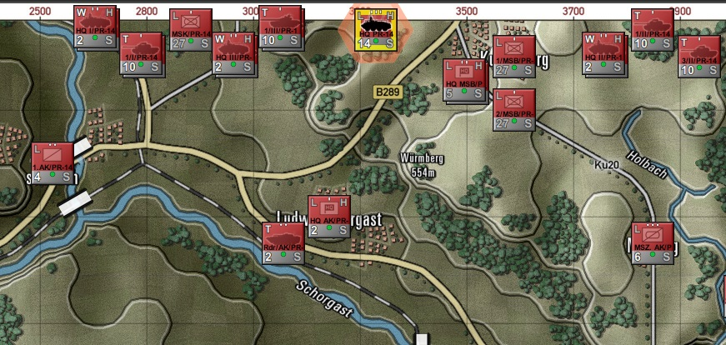

Figure

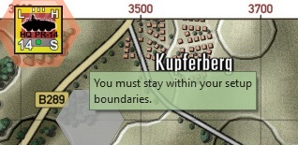

Figure

Figure 120 shows a highlight unit that has a larger size setup zone. You can then move that unit to a different location on the map.

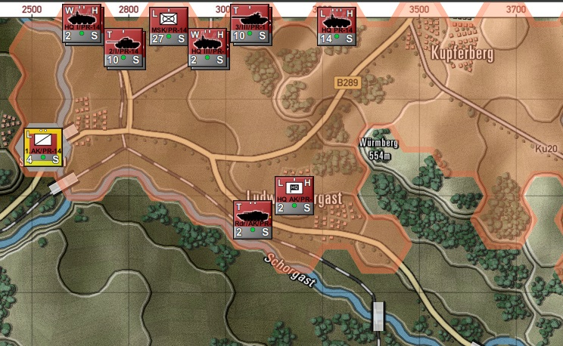

Figure

## Player 2 Order of Battle

After deploying all Side 1 units on the map or positioning them off the map, click the Next button at the bottom of the dialog to proceed to the units for the "Warsaw Pact" forces in the scenario. Follow the steps outlined in Sections 4.5 through 4.9. Once you've completed the forces for side two, click the "Next" button to move on to working on the Player Briefings, as illustrated in Figure 121.

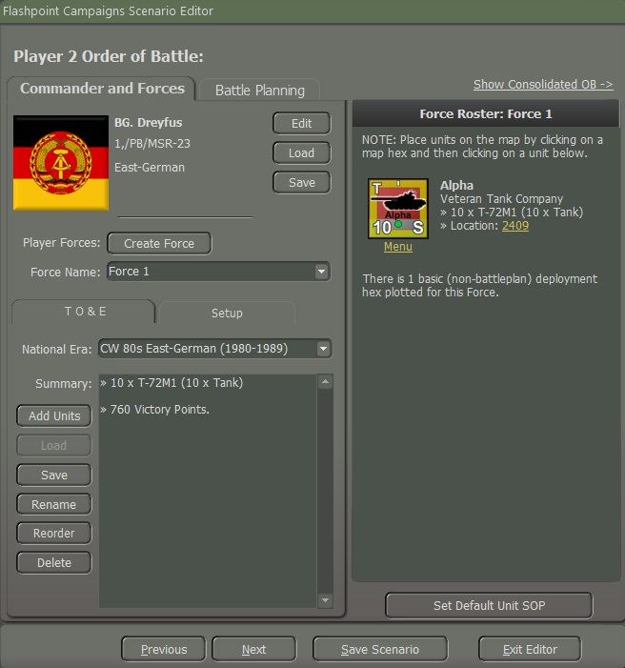

Figure

## Player Briefings

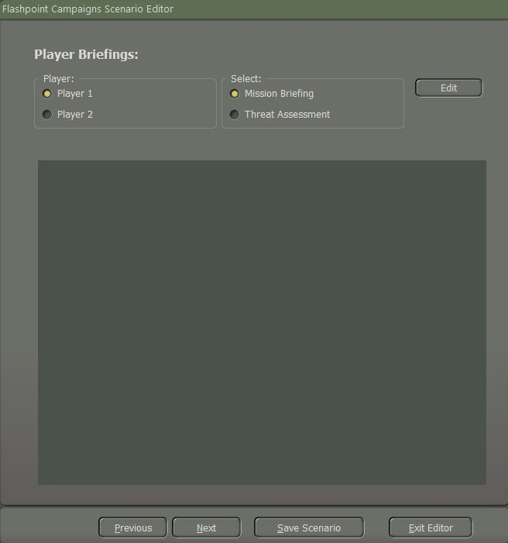

Figure

Once you click the “**Next**” button after setting both player sides a popup window “Player Briefings” is displayed as shown in Figure 122.

1. This selection allows you to select which side Scenario Briefing is being displayed and worked on.
2. This selection allows you to switch between the Mission Briefing or the Threat Assessment for the selected side.
3. Click the “**Edit**” button to open the window on the right with the plain text editor. This editor can use simple HTML 5 tags in the text. See “**Section 8 HTML Quick Preference**” for HTML tags.
4. This window shows the current generated Briefing or Assessment based on the selections.

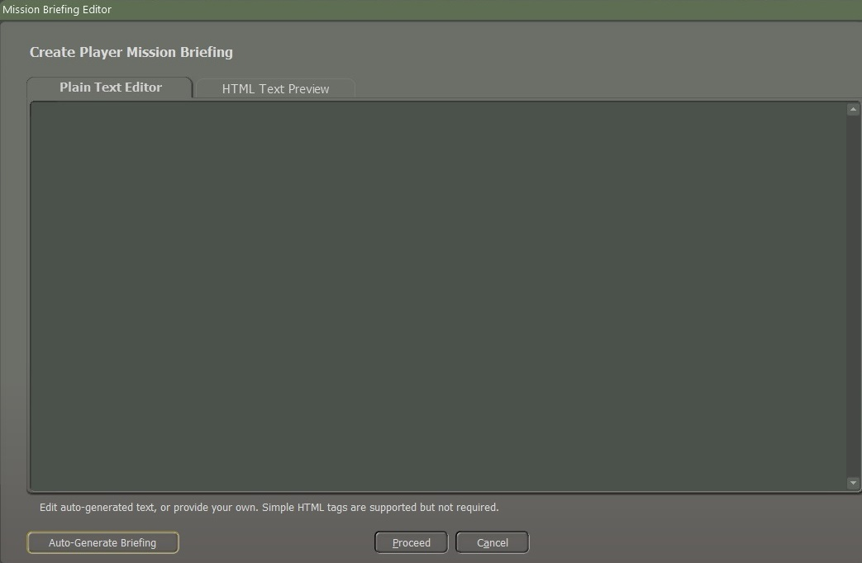

Figure

1. This tab window is the plain text editor for you to write the various Briefings and Assessments as shown in Figure 123. You can write your own or edit the Auto-Generated versions made by clicking the “**Auto-Generated**” button at the bottom (**7**).
2. Switching to this tab will show the actual display version of the plain text window if HTML tags are used.
3. Clicking this button will Auto-Generate either a Briefing or Threat report based on the selections for the selected side based on our provided template. You can add, edit, or remove anything from these templates to fit the narrative of your scenario.
4. When you are done with your edits for the Briefing or Assessment click the “**Proceed**” button to save these edits or cancel to return to the Selection Dialog.

Figure 124 shows the Auto-Generated Player Brief by clicking the “**Auto-Generate**” button.

You can edit the content in the Plain Text Editor Window and look at the actual output in the HTML Text Preview as needed.

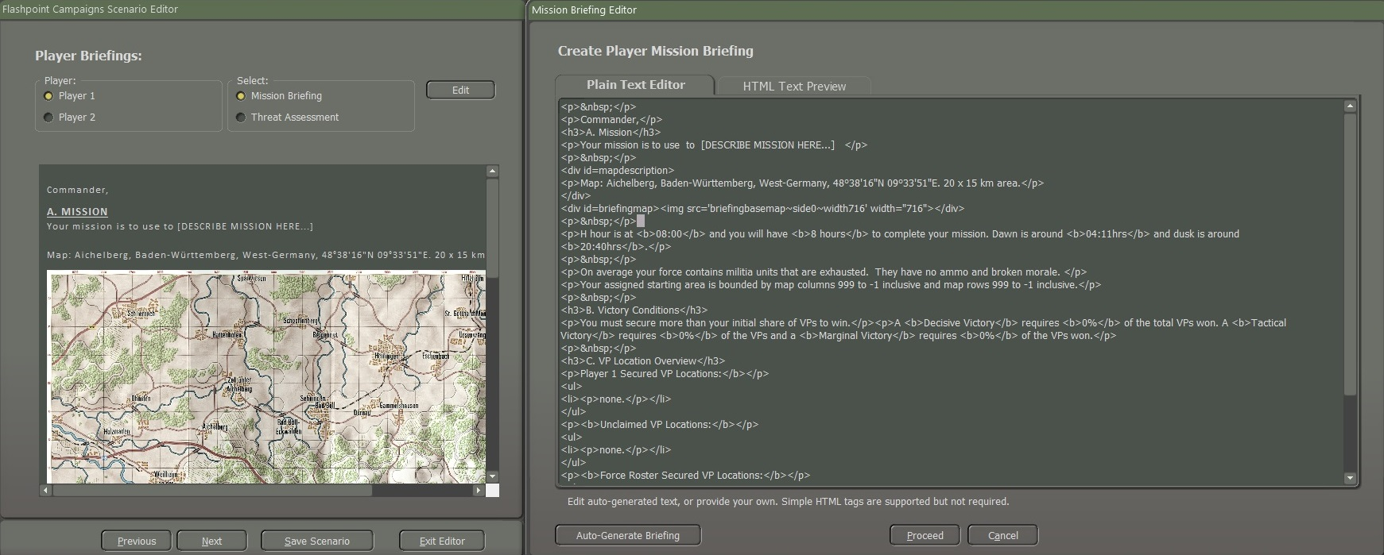

Figure

Figure 125 shows the auto-generated Threat Assessment from clicking the “**Auto-Generate**” button. You can edit the content in the Plain Text Editor Window and look at the actual output in the HTML Text Preview as needed.

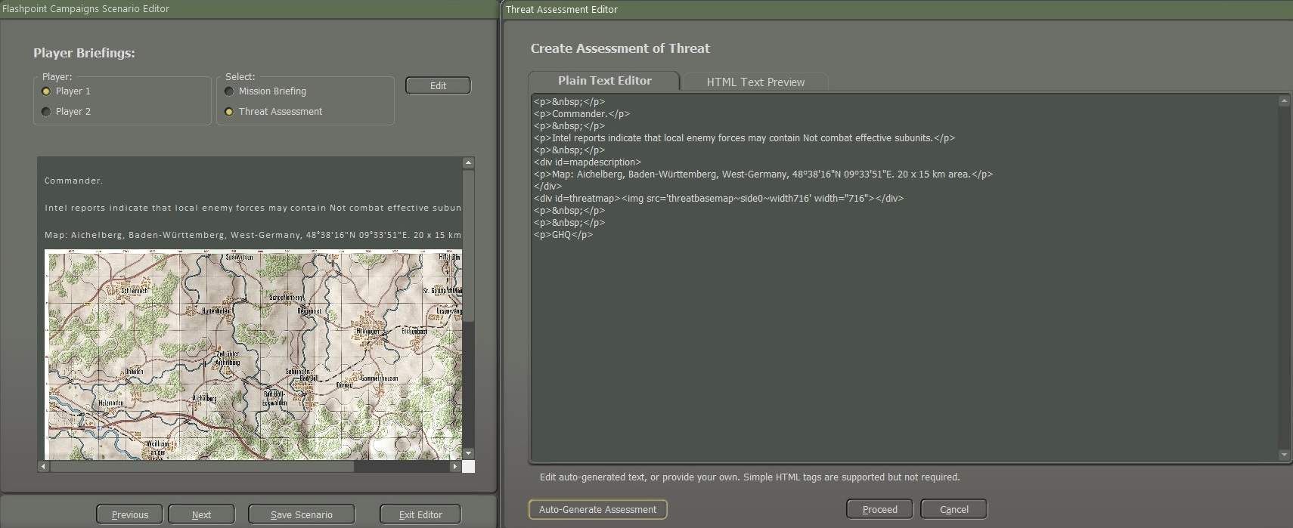

Figure

**NOTE:** If you make changes to any of the forces in the scenario, you will need to adjust the numbers shown in the briefings or redo the briefings with the auto-update and add back in your details.

### Best Practices for Mission/Threat Briefs

The following pointers are offered to help scenario designers with their briefings.

* Using the templates can help make sure you are giving the players all the essential information for their side of the scenario.
* Keep the information focused on the details and keep the items short in length.
* Focus on the key points of the mission that the player needs to know and accomplish.
* Threat assessments can be made either vague or detailed depending on how you see the pre-battle intelligence of the battle. Sometimes the intel folks are wrong or some of the details are misunderstood.
* The mission briefings should follow the scenario narrative that you wrote in the Scenario Description panel, but you do not need to repeat all that information. Focus on providing the side specifics details.
* Make this one of your last items to do after scenario testing, to avoid missing details in forces if you edit items in the scenario.

## Mission Graphics

Mission graphics are crucial in scenarios to improve the player's situational awareness, enhance immersion, and facilitate effective communication of mission-related information. These visual elements contribute to the overall gaming experience and play a key role in guiding players through complex scenarios and objectives.

Open the Scenario Editor select Scenario and load the scenario. When the scenario is loaded go to the Counters tab and select “Hide unit Counters” as shown in Figure 126.

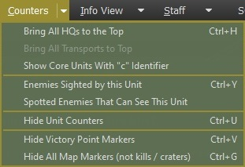

Figure

Next, go to the “Staff” tab and select “Copy Map to Clipboard for Mission Graphics” as shown in Figure 127

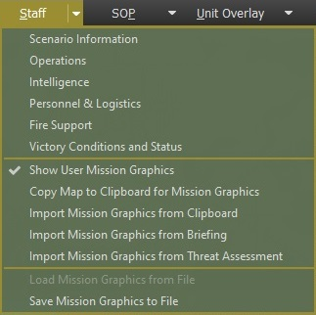

Figure

Once you copy the map, open PowerPoint. Paste the map into a PowerPoint (or an equivalent) slide. Draw a box with no fill over the map. Add the mission graphics like the ones shown in Figure 128, and Figure 129.

Delete the map after finishing adding the graphics, by grabbing the map with the left mouse button to one side so that you see the box that you made with no fill. Right-click on the map and select delete. You will have just the slide with the mission graphics on it.

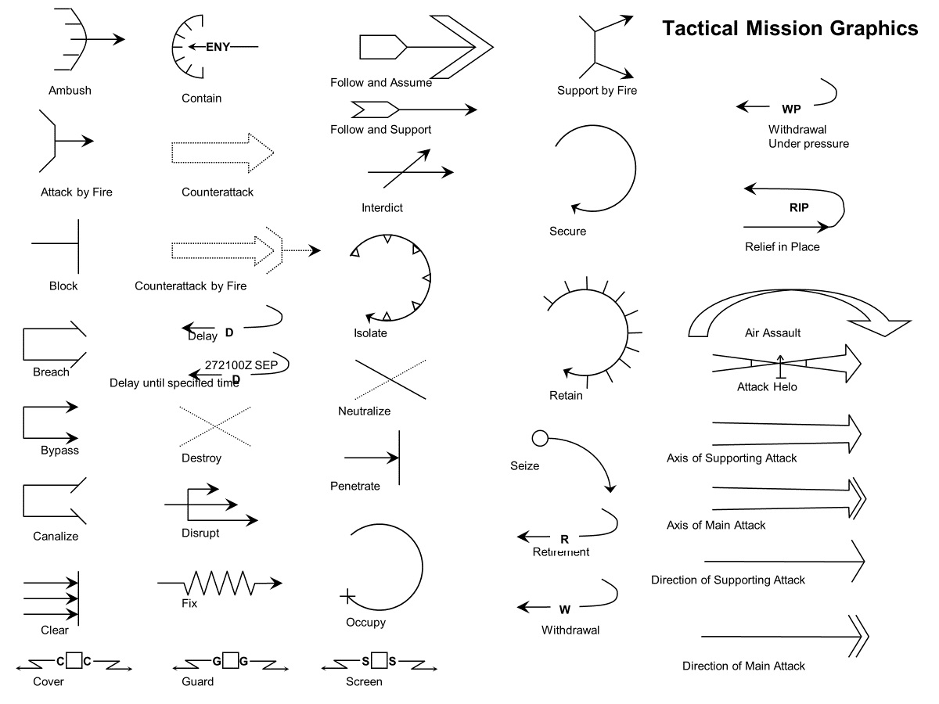

Figure

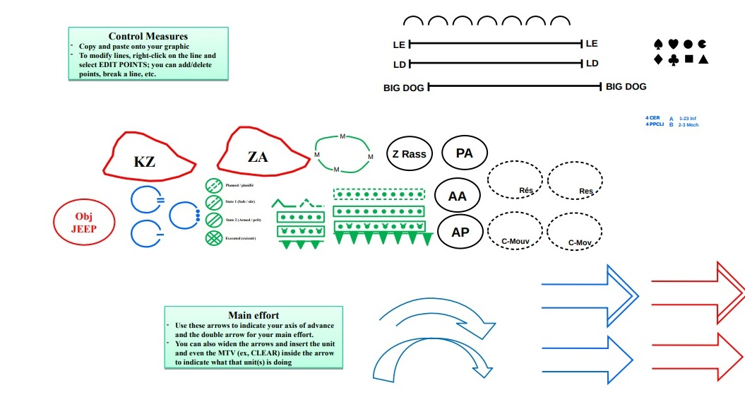

Figure

Copy and paste onto a Paint program, for example, I use Paint.net. Use the magic wand select the white area on the slide and then select the “Delete” button on the keyboard. The white area will be transparent. Figure 130 shows an example of a finished Mission Graphic.

Save the file as a .png file in the folder for that scenario. The four file names with side 0 as NATO and side 1 as WP as shown:

* briefingoverlaymap~side0
* briefingoverlaymap~side1
* threatoverlaymap~side0
* threatoverlaymap~side1

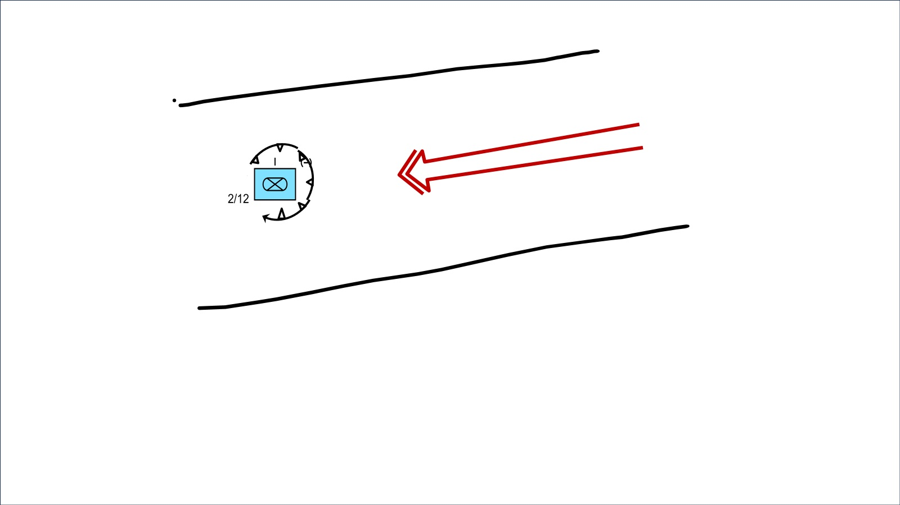

Figure

The result from the example is shown on the map as illustrated in Figure 131.

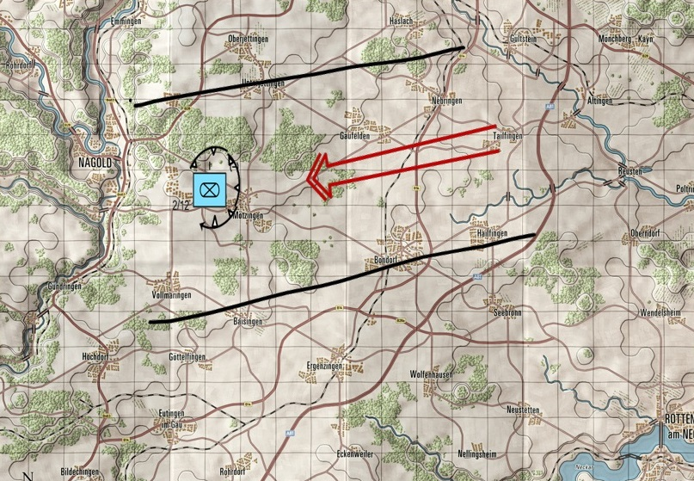

Figure

To create the unit symbols as shown in Figure 131. Select the link “How to Create Unit Symbols will take you to the website as shown in Figure 132. [How to Create Unit Symbols](https://spatialillusions.com/unitgenerator/#30031000000000000000)

Once you have made the icon, save it as a .png file by clicking on the (**1**) PNG symbol as shown in Figure 132.

Once you have saved it as a .png file, copy the .png and paste it on the overlay, and then adjust the size and move it around to the location where you want the placed place.

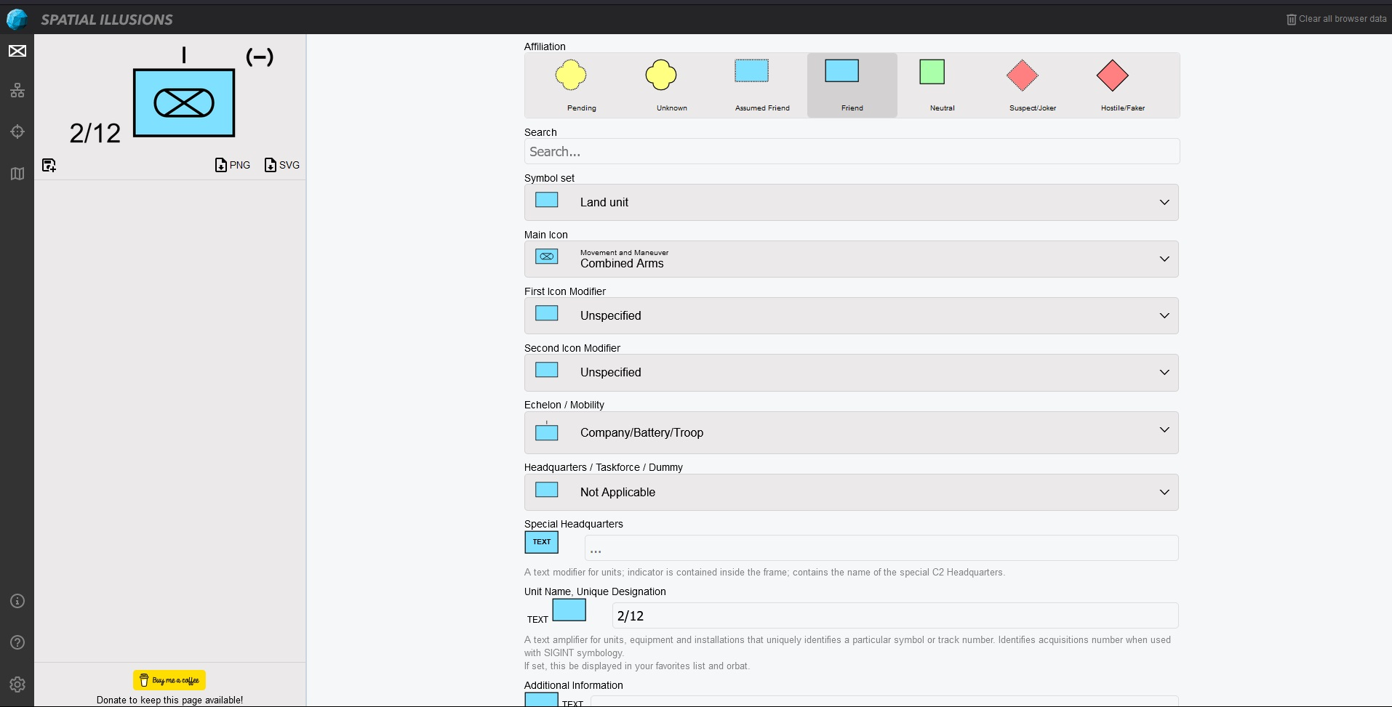

Figure

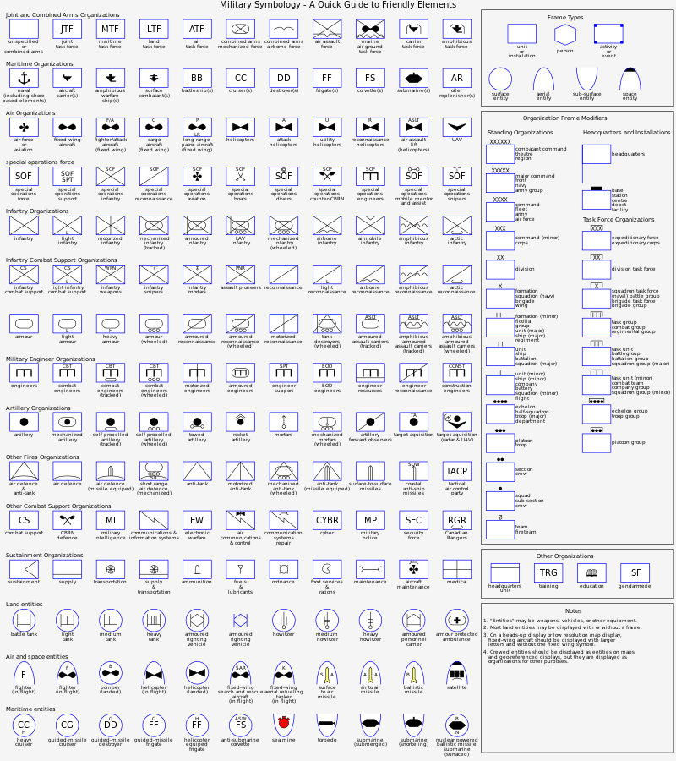

Figure

Figure 133 shows “Military Symbology – A Quick Guide to Friendly Elements” for reference when using the NATO symbol generator.

## Scenario Summary

The dialog below outlines the Distribution of Units and the breakdown of Victory Point scoring for the scenario as designed. The breakdown of the dialog is as follows as shown in Figure 134:

1. This window shows the “Distribution of Subunits” for both sides by type and number by graph. At the bottom of the window, there is a total of four subunits on both sides.
2. This text area breaks down the “Victory Points” (VP) for each side and any owned locations on the map.
3. The table in this window shows the breakdown by VP percentage to achieve the given result in the scenario. This ratio is based on the VPs on the map and the number of VPs for the units.

This ratio mechanic allows you to make “unbalanced” force scenarios and provide a balanced result for the battle.

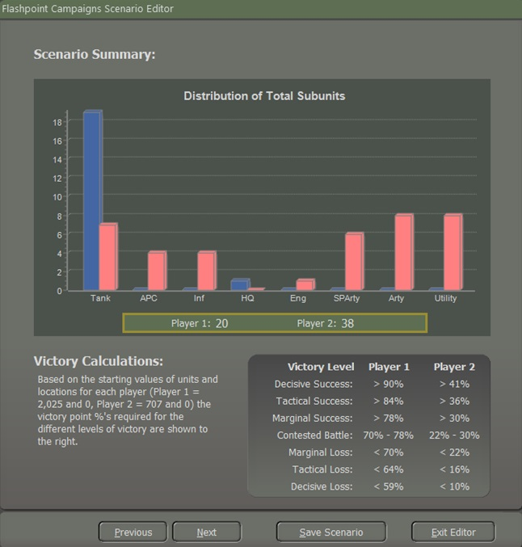

Figure

Click the “**Next**” button as shown in Figure 134, to move to the next Dialog screen.

## Scenario Details and Validation

The last dialog in the Scenario Editor is the Details and Validate page as shown in Figure 135.

You can do the following functions here:

1. In the Author Details area, you can enter your Name (real name and forum handle), Contact information (an email address if you want folks to contact you or leave it blank), Date Started (you should populate with the date you start working on the scenario), Last Revision (date auto populates with today’s date), Notes (Any info about the scenario or changes made in the revision).
2. The Scenario Validation area notes any issues that must be resolved before your scenario is playable in the game. Click on the “**Update**” button any time you make changes to see what items are still needed for a complete scenario.

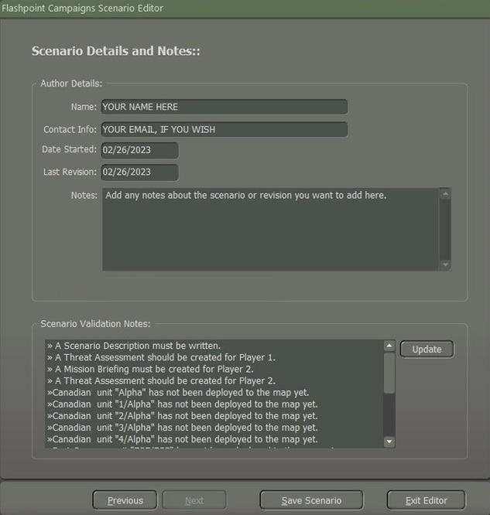

Figure

**NOTE:** Even though you can save an unfinished scenario in the editor (after adding the minimal information as noted in the dialogs that pop up), they will not load in the game. A warning message will pop up notifying it cannot be run as currently designed.

# Battle Plans

We are going to show what Battle Plans can do to make scenarios or campaigns have more replayability options to a scenario. **FM05:** **Battle Planning** will have more details on how to make them.

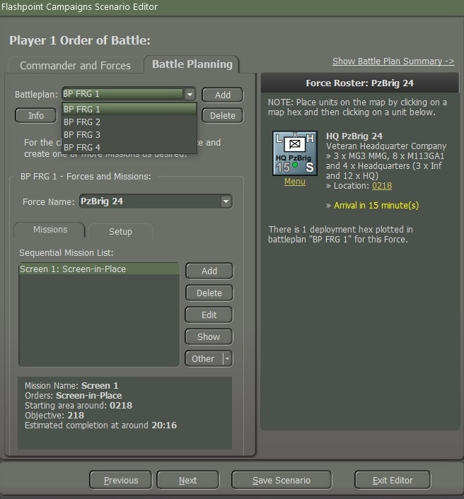

Figure

Additional Battleplans can be added to scenarios to increase the replayability of any given scenario further.

SOP adds a section and notes that the designer should set reasonable SOPs for units in each battle plan. The best way would be to use the menu and select by unit type and mission which will be covered in **FM05:** **Battle Planning.**

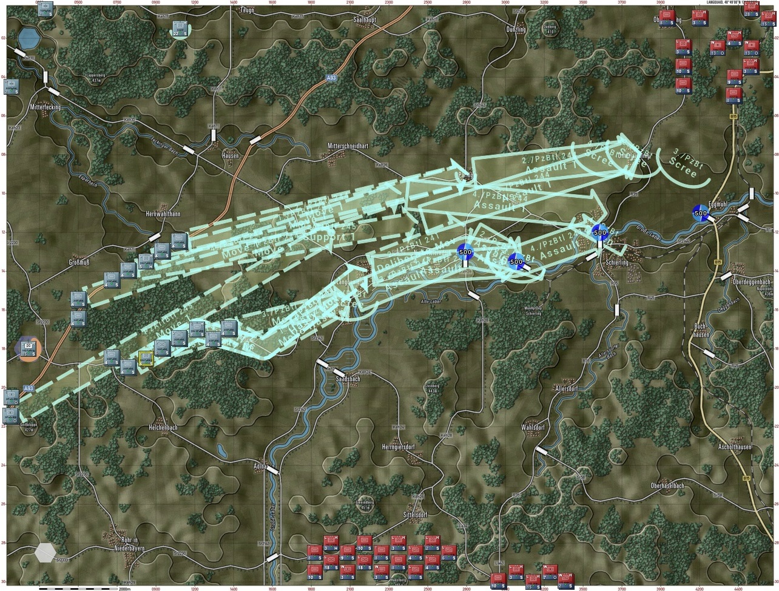

Figure

# Altering an Existing Scenario

Altering an existing scenario generally refers to making changes or modifications to a pre-existing situation or set of circumstances.

How to load an existing scenario and then step through and edit it. Also, cover the Data Update and Excel import/export functions for adjustments.

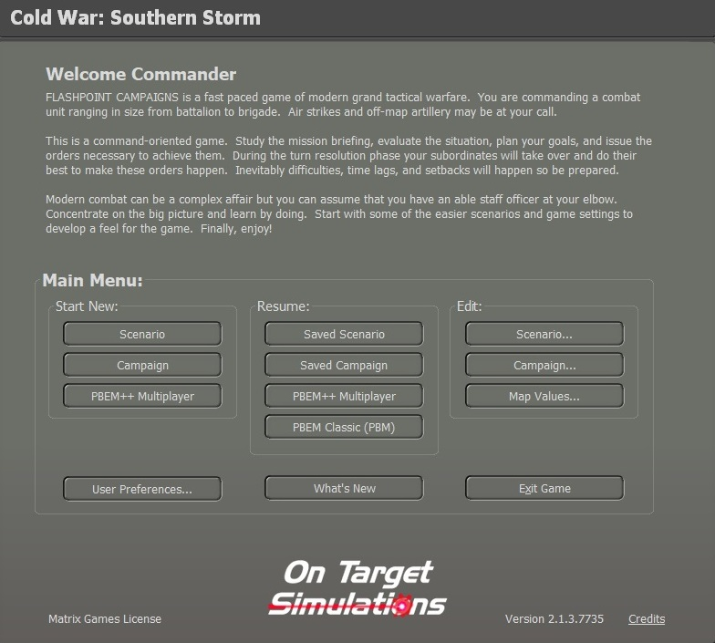

Figure

**NOTE:** If you are going to make changes to existing scenarios change the name and refer to it in the “Scenario Details and Notes”.

At the Main Menu\Edit select the “**Scenario**” button as shown in Figure 138 to bring up the “Scenario Creation Checklist” as shown in Figure 139 and select the “**Load** **Standalone Scenario File**” button as shown in Figure 139. That in turn will bring up “Select and Load Standalone Scenario File”. Here you will select the scenario that you want to make changes to.

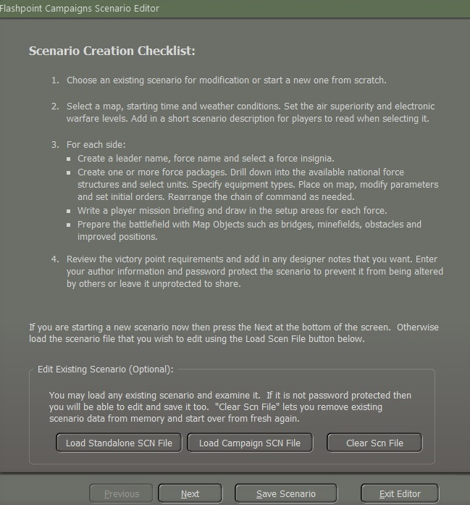

Figure

For this example, we will select the West German scenario “Lessons of War” and then select the “**Proceed**” button as shown in Figure 140.

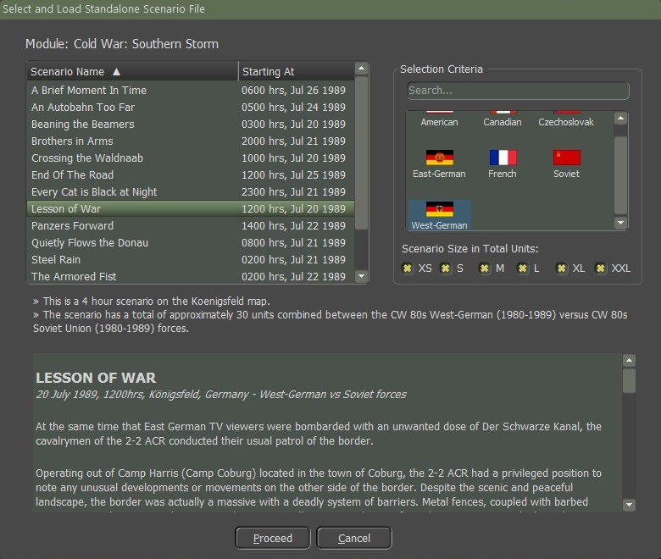

Figure

After the scenario is loaded and before selecting the “**Next**” button, you should save the scenario file with a new name by selecting the “**Save** **Scenario**” button as shown in Figure 141.

For this example, I will name the new scenario “Kriegspiel” and then select the “**Proceed**” button as shown in Figure 141.

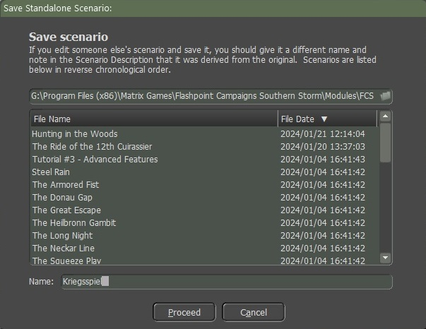

Figure

Once you select the “proceed” button you will get a confirm popup screen then click on the “**OK**” button as shown in Figure 142 to take you back to the scenario to start making your changes.

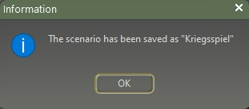

Figure

You can make changes to the scenario as you did when making a new scenario as shown in “Section 4 Creating a New Scenario”. The last screen that you will see when you finish making the changes is the “Scenario Details and Notes” as covered in “Section 4.13 Scenarios Details and Validation” in the Notes box need to give credit to the original scenario.

## Editing Scenario using XLS

Sometimes when working on a scenario it can be a pain, for example, when you want to replace one type of equipment with another. The XLS Export/Import function was developed to help with this.

For example, in a scenario, there were nine M109G and we will reduce the number of SPArty subunits in a West German Artillery Battery from nine to six.

Load the scenario into the Scenario Editor and pull down the Scenario Editor>Export Game Data to .xlsx file menu item as shown in Figure 143.

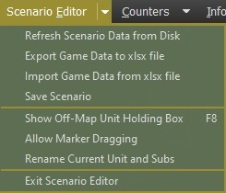

Figure

Read the warnings and limitations then select the “**Proceed**” button as shown in Figure 144.

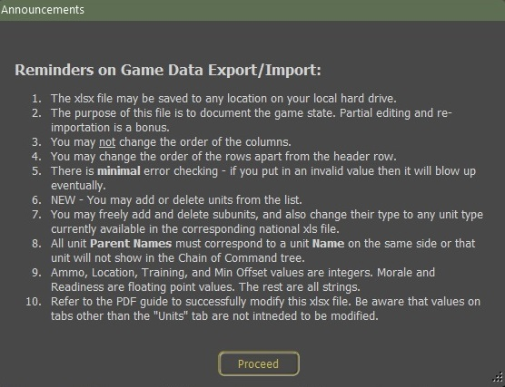

Figure

Save the file to disk. By default, the file name is based on the scenario name, and it will be placed into the \Modules\FCSS\Scenarios\ folder as shown in Figure 145.

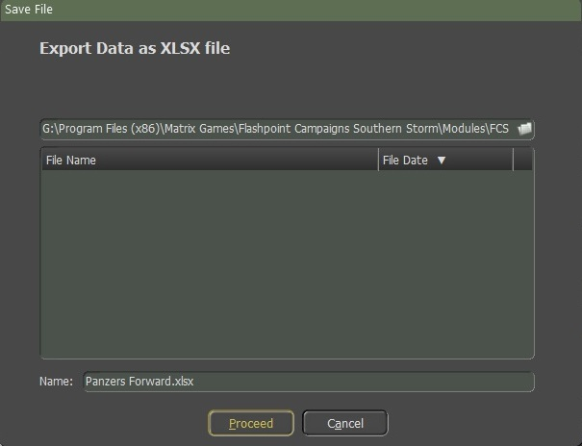

Figure

Open the XLSX file in Excel or an equally capable program. Select the “**Units**” Tab as shown in Figure 146. You can look at the other tabs, but changing entries in them may wreck your game when you import the file back into the scenario.

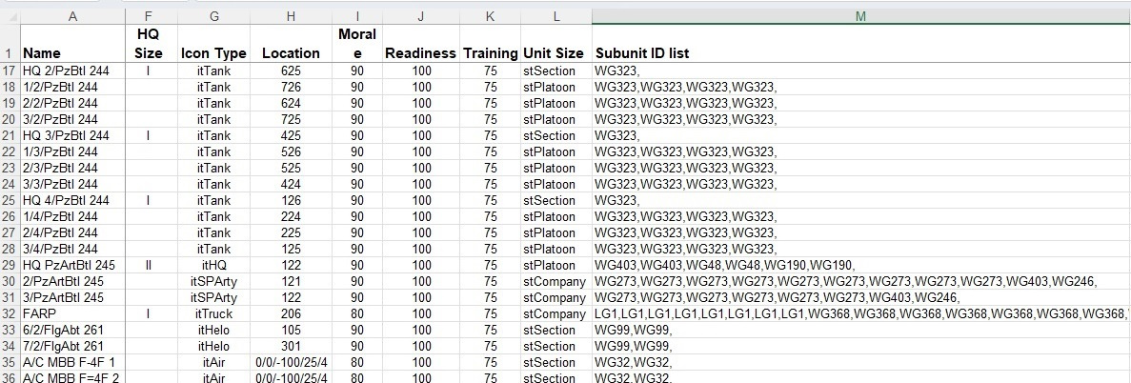

Figure

Each unit is a row in the spreadsheet and each column is an item of data for that unit. You want to look at column “M” “Subunit ID List” as illustrated in Figure 146. You will also need to look at column “U” to see what the National Data Filename is. You will need to know which data file to reference for a given unit to make the changes to validate them all in this example it will be CW 80s West-German xls which will be located at \Modules\Common\Data\Nation, once open, go to the “Units” tab, column “A” for the SUTag values that you will need to add/replace in column “M” of the .xlsx file for that scenario you’re working on. In this example, you will be looking for WG273. “Section 7 Updating Scenario Data” will go into more detail.

You want to look up and find the unit you want to change by its name from column “A”. In this case, it is 2/PzArtBtl 245is the artillery unit we want to edit as shown in Figure 147.

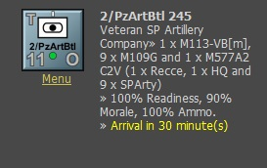

Figure

The subunit ID corresponds to the codes contained in the relevant national data .xls file for that unit. In this example, we see “WG273” repeated nine times. These are the nine SPArty subunits that we want to change.

Edit this cell to remove three of the “WG273” entries. A comma must remain between all subunits in the list. There must be a trailing comma at the end of the list for it to be parsed correctly. Spaces for readability are optional.

In this example, we were just removing three subunits. If needed we could change the model of the M109 used, we could do an Excel Search and Replace to change instances of WG273 to something else instead. We could also add new subunits to this or any other unit.

When you’re done editing your scenario spreadsheet then save the xlsx file to disk.

Now we will Import the file back into the scenario by selecting the Scenario Editor\Import Game Data from the xlsx file to reload the scenario data as shown in Figure 143.

You will get a popup screen stating a reminder of caution and then select the “**Proceed**” button as shown in Figure 148.

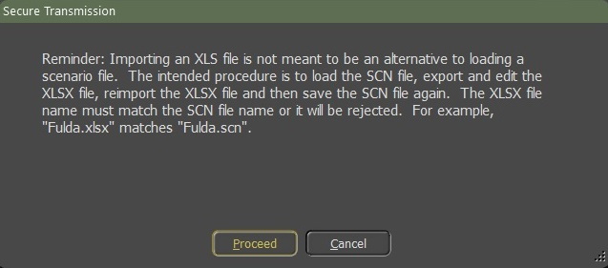

Figure

A screen “Import Data from XLSX file” will displayed and you must highlight the scenario name, for this example, we will highlight the Panzer Forward xlsx file and then select the **Proceed**” button as shown in Figure 149.

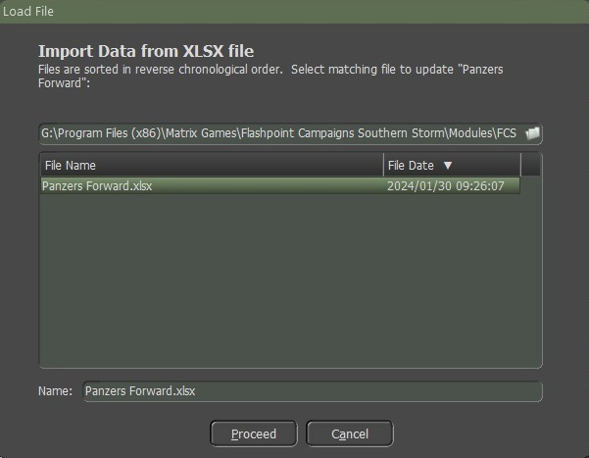

Figure

The correct scenario must already be loaded into the “Scenario Editor” for this to work. The file will be imported and parsed, and the scenario editor will be updated or may crash if the data is wrong. You can now browse the unit and check that your edit had the desired effect. Save the scenario in the normal way or your changes will be lost.

# Updating Scenario Data

Just to reiterate you can only do a Refresh in Scenario Editor mode not during the actual turn. To update a scenario data, go to the Scenario Editor and select “Refresh Scenario Data from Disk” as shown in Figure 150.

**NOTE:** You only need to do this if “**your**” scenario needs to be updated with a new National Era Data. If there is new data, it will be automatically updated to the scenarios that came with the game.



Figure

Once you click on the “Refresh Scenario Data from Disk” a popup screen will state “Keep previous unit ammo load packages intact?” If you click the “**Yes**” button you will keep the ammo load as is, if you click the “**No**”  
button it will revert to the default load. If you click on the “**Cancel**” button it will not proceed and will cancel the refresh scenario data. We will click on the “**Yes**” button as shown in Figure 151.

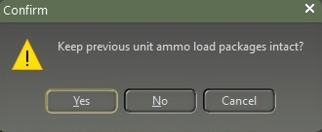

Figure

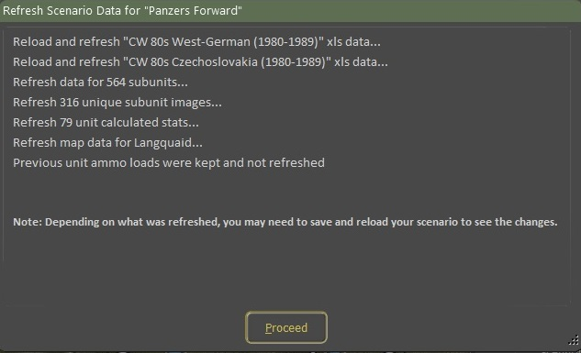

Figure

After you select the “**Yes**” button a popup screen will appear loading the new data. For this example, we refresh with the scenario “Panzer Forward” as shown in Figure 152, and then select the “**Proceed**” button.

**NOTE:** depending on what was refreshed, you may need to save and reload your scenario to see the changes.

# HTML Quick Reference

Here is an example of my Scenario Briefing that I made for a scenario as shown in Figure 153.

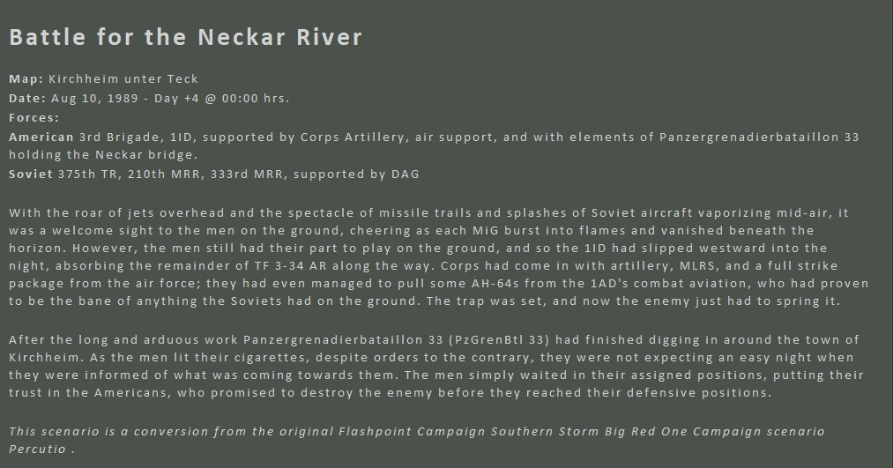

Figure

Looking at Figure 154 and Figure 155 show the HTML codes that I used to make the Scenario Briefing.

Some of the codes will work, some won't. You must do a trial and error to get the right code needed.

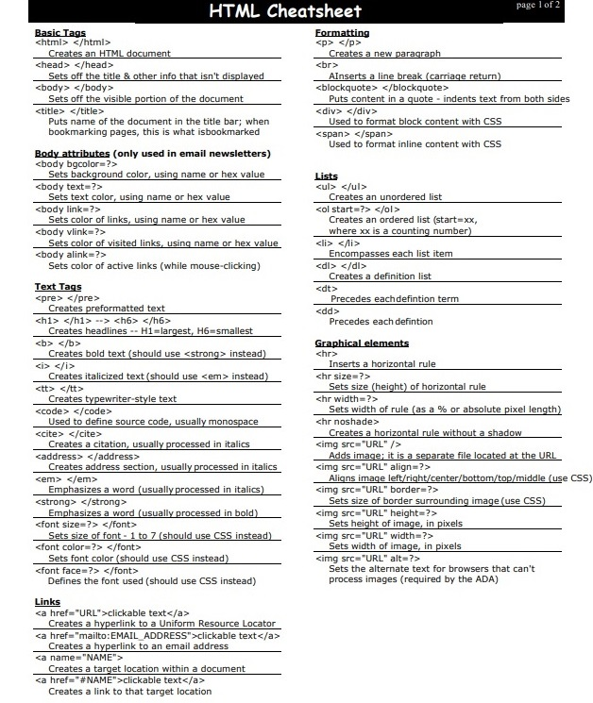

Figure

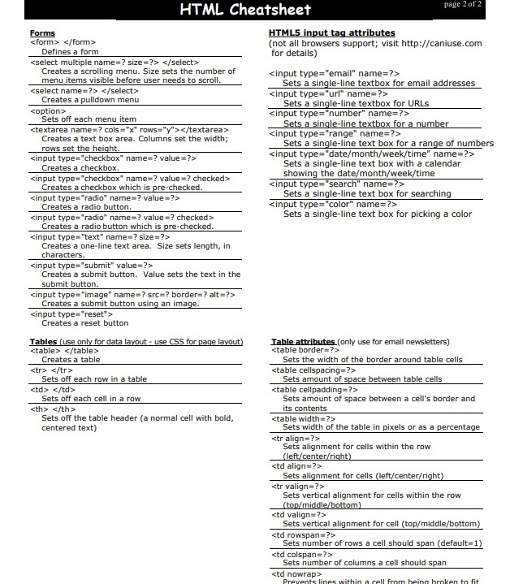

Figure

Figure 156 shows the code that was typed in the “Create Scenario Description, Plain Text Editor and the results shown in the HTML Text Preview as shown in Figure 153.

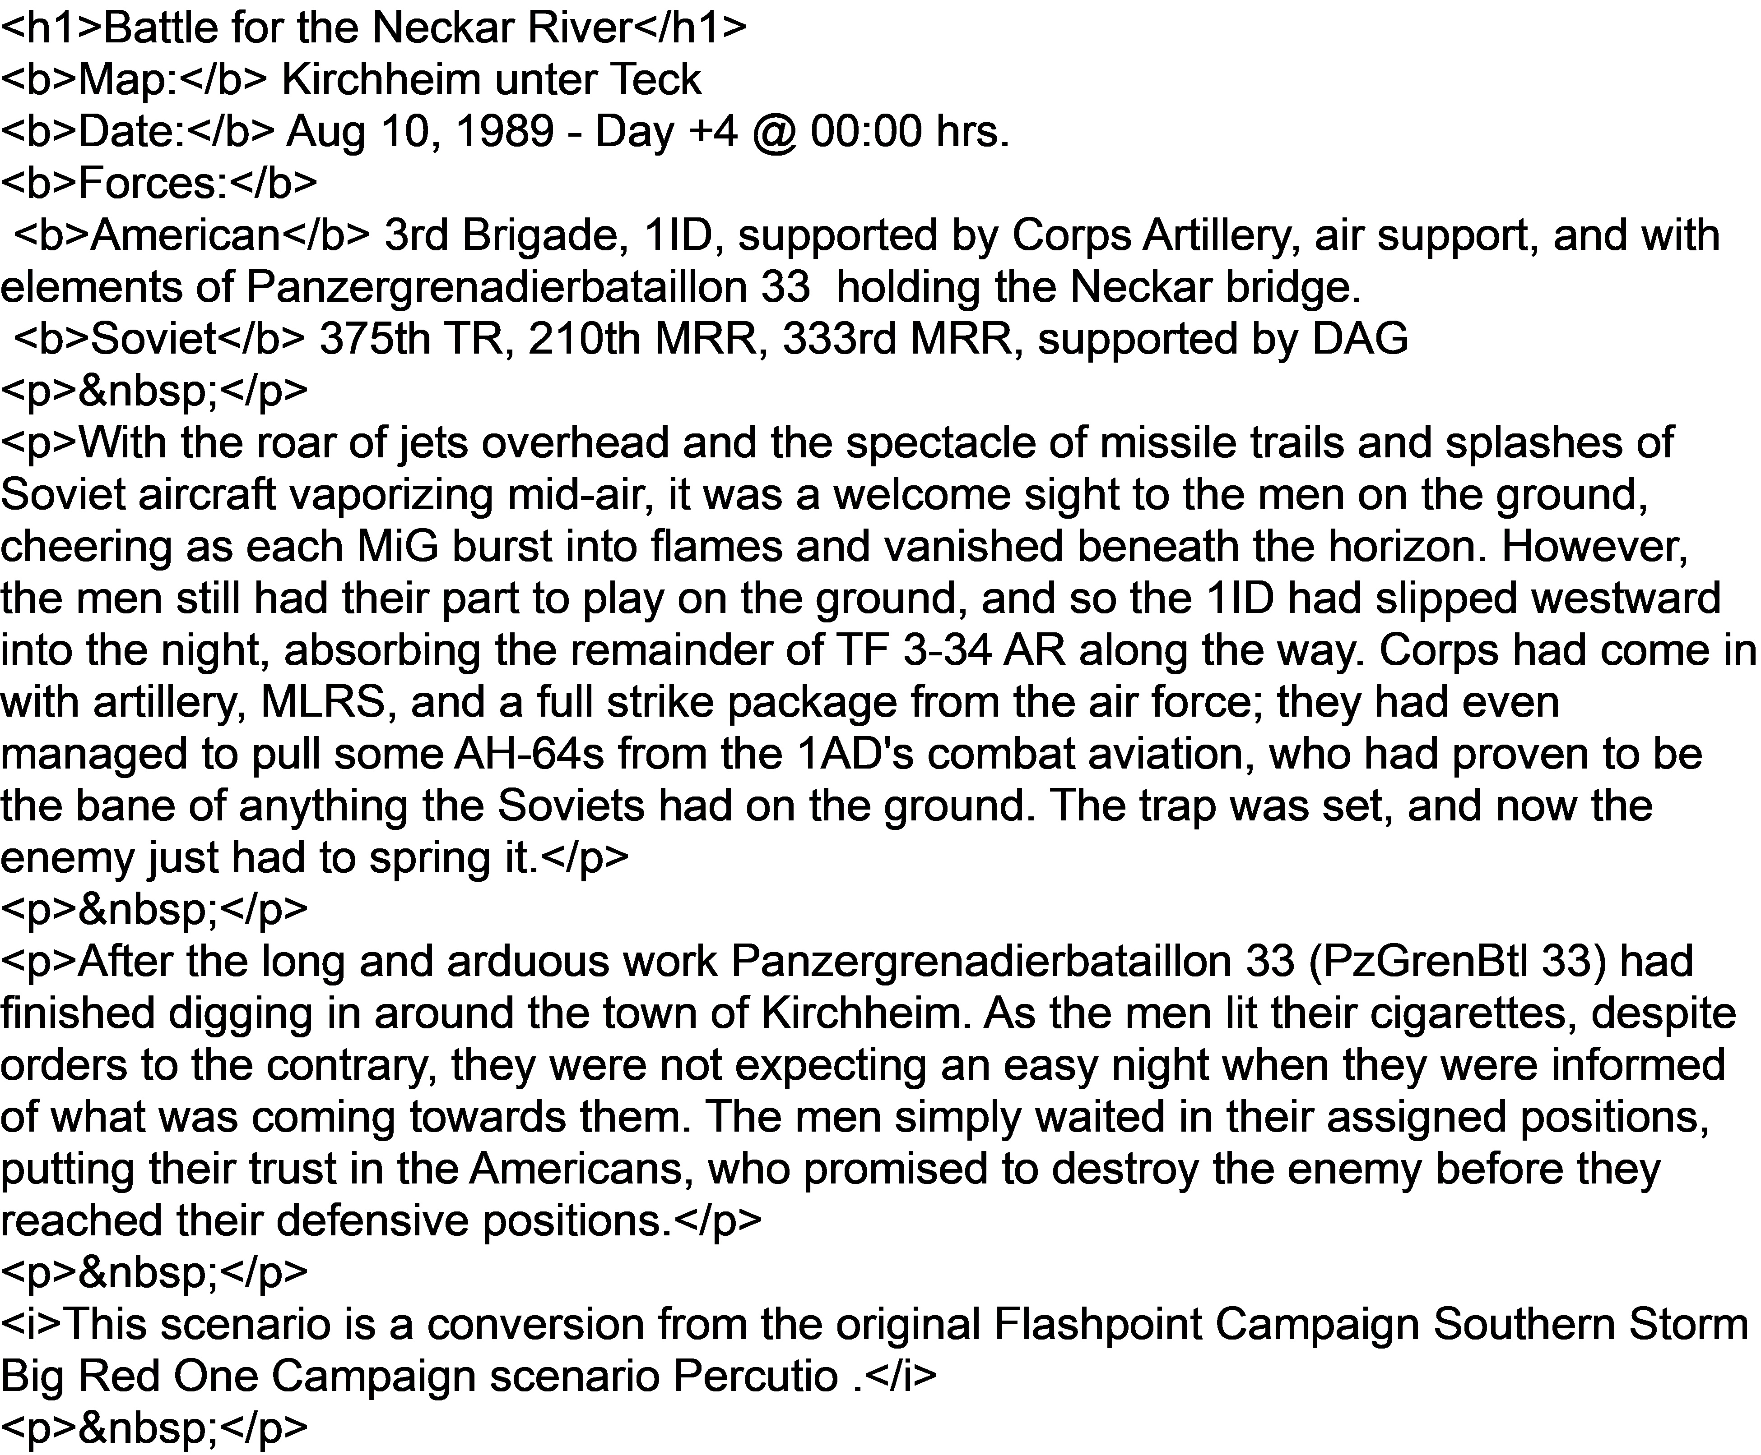

Figure

# Some Scenario Design Do’s and Don’t’s

I start all my scenario design in PowerPoint with an overarching plan - highlighting the forces and making sure that I know where they have been fighting in recent days, etc.  I want to make scenarios that are realistic, challenging, and fun.  I try to map out the scenario in PowerPoint, showing where the forces will be coming from, and what they are trying to do.

Once the first draft of the scenario is done - test it a couple of times with the AI playing on both sides. This gives you a chance to see BPs and a good view of the overall flow.  Then, I play one side against BP and make any tweaks.  Then the other side.

I have discovered that the scenario can be different with the BP from where the player will start.  For example, a Soviet BP may start with an Motor Rifle Regiment farther West than the player gets to start.  This helps with balancing, and I find can make it more fun.

I try to wait until I get a bunch of feedback before making too many changes.  Sometimes one person says it is too tough for the NATO player and a second one says it is too easy.  I'm looking for a balance.

Take the time to set the SOPs for all units.

Don’t place units where the player is likely to deploy them in the pregame setup, place them in a location out of the primary area.

You must start with a clear idea of what you want the scenario to be (i.e., meeting engagement, the attack against the dug-in defender, etc.) which is the first step towards understanding what the forces will be.

Define the OOB before you start battle planning. It just creates further difficulties if you do not do so. Adding a unit to an existing force is simple enough, adding a force starts to become complicated as you will then need to make sure you deploy them in every single BP, adding orders, etc.

Make good use of the 'use this for all' button on the SOP battle planner. This avoids repeating the same SOP on and on for every single similar BP order you add.

Don't forget, any order you add (for ex, you added a new force to the OOB) after finishing the BP will need to have its SOP done from scratch.

Be careful with EW settings as it may have a dramatic effect on order cycles. Order cycles above 20-40mins need to be looked at to make sure they are shortened.

There is scope for some units to be left under AI control. You don't need to BP every single force but, on the other side of this coin, the AI will use its judgment for their usage, so, any fundamental or core units should have a BP. I usually only leave the odd support unit free for the AI to use.

Carefully read the manual with regards to how the AI uses BP orders and what happens if it cannot complete an order or when your BP orders finish. It's important to grasp this to understand what you sometimes see on the screen.

Once you have the scenario complete, I would like to do some runs of AI-vs-AI testing. This normally flags any obvious mistakes with BPs, reinforcements, deployment, etc.

Often forgotten, be sure to set the loads of your arty units.

# Flashpoint Campaigns Credits

## On Target Simulations

* Lead Programmer and Head Honcho: **Robert "Ironman" Crandall**
* Data, Programming, Graphics, and Sound: **Jim "Cap’n Darwin” Snyder**
* Programming, Data, Models, and Research: **Jeff “Iron Mike” Sugden**
* Map Master, Programmer, AI, and Graphics: **William van der Sterren**
* Quality Czar and Testing Lead: **Charles “The Whip” Belva**
* Programming: **Kevin “SgtZDog” Zemon, Will Jackson, Alex Kriesel**
* Testing: **Tomasz Niedzinski**

## On Target Simulations Content Team

* Alexander “Stimpak” Schwarz, David “22sec” Whitt, Mike “MikeJ19” Johnstone, Joao Lima, Jurrie van der Zwaan, John “JohnO” Osborne, Jorgen “Jotte” Torgersson, Jo van der Pluym, Scott “WABAC” Gibbs and Steve “Mad Russian” Overton

## Cold War Beta Testers

* Names to be added before release

## Matrix Production Support

* **Erik Rutins, Maxim Klose-Ivanov**

# OTS on the Web

Matrix Games Forum: <https://www.matrixgames.com/forums/viewforum.php?f=10149>

Check Us Out on Discord: <https://discord.com/channels/911711314051739659/911711314257248331>

Check Us Out on Steam: *“Pending a page URL*”

**© 2025 On Target Simulations, LTD. All Rights Reserved. The images used and OTS Logo are property of On Target Simulations, LTD. All other logos and trademarks are the property of their respective owners.**